**Assignment 2 – Web Development**

**Gathering Information**

**Introduction to Brief**

As a Junior Web Developer for Hot Beans, my latest assignment is to create a segment of new job advertisement websites for the company. The problem definition is to create a section for the company’s website to promote the company to prospective employees as they are looking for recruitment for Junior and Senior Web Developers. The statement of requirements includes 5 sections:

* A Profile for the company itself
* Profiles of existing trainee web developers
* Job Specifications and Required Qualifications
* An Online Application Form
* Links to Web Development Course

**Target Audience**

This website’s target audience specialises for those from the ages 20 – 25, who have most likely recently finished their university course in web development or software engineering and are looking for employment in this field. We are hiring both junior and senior web developers. The experience category varies, as we hire those who are looking to gain hands on experience, as well as highly experienced individuals who are seeking new employment.

**Summary of the Problem**

In summary, I need to create a small section of a website that includes 5 tabs. The website should meet all user, client and purpose requirements, and serve as a fully functioning website with seamless navigation and highly quality design.

**Constraints**

The constraints are that certain aspects of the website must be included to complete this task. These are:

* A Profile for the company itself
* Profiles of existing trainee web developers
* Job Specifications and Required Qualifications
* An Online Application Form
* Links to Web Development Course

The other more general constraints I will face include, time, technical limitations, compliance, user needs, and prioritisation of features.

**Benefits**

The development of this website will provide many benefits for Hot Beans, providing employee’s a secure job at the company. This will result in more people wanting to apply for the job, leading to a higher level of applicants. This website will optimise the recruitment process, as employers will be able to see candidate skills, experience, education and extras without any direct contact with them. This also enhances time efficiency, as employers do not have to spent time contacting candidates to get information. One of the most beneficial aspects of this website is the ability to target specific jobs, while reaching a large audience. The navigation and trending features of the website will allow candidates to search for specific location, pay and type of job they want, while all being the field of web development. Lastly, the website benefits me as a web developer as it gives me the opportunity to create a section of this website, providing me with experience and knowledge as a web developer.

**Nature of Interactivity**

My website will include multiple sections of interactivity, such as buttons and text boxes. To meet the objectives of the brief, I will need to include navigational links, hyperlinks to other pages, an interactive online application form and others. The others would increase the optimisation and overall design of the website, e.g., animations and sideshows.

**Complexity of the Website**

The design of the website to provide simple, but detailed navigation, to prevent it being boring and to keep the user engaged. All aspects of my website put together will create a complex, well-designed website.

**Client Requirements**

The basic requirements that Hot Beans would like to include are:

* A Profile for the Company itself
* Profiles for existing web developers
* Job Descriptions and Required Qualifications
* Online Application Form
* External Links
* Appropriate Design for a Target Audience
* Brand Showcase

**User Requirements**

* Easy Navigation and Use
* High Performance Speeds – The website will be optimised so loading times are reduced, to ensure that the web runs smoothly without errors
* Interactive Website - The website should include features that allow users to interact with the website, including hyperlinks, text boxes, slideshows and buttons.
* Engagement – Preventing the user from being underwhelmed and disengaged

**Purpose Requirements**

The purpose of the website contains a few expectations:

* The content is appropriate for the company and the target audience
* The website provides easy navigation
* The layout of the website must be mostly filled with information, but a correct balance of empty space and text
* The website should maintain consistency, including fonts, colour themes and layout
* Images and Videos must be selected to the target audience

**Planning & Website Design**

**Initial Design**

I have drafted 3 initial designs from which I will select 1 design to become the final design.

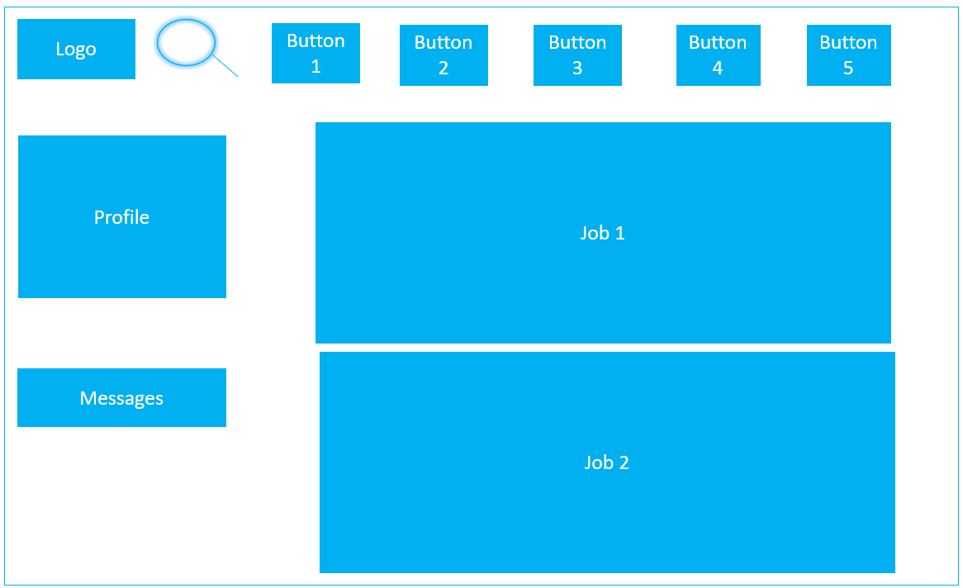**Initial Design 1:**

This design focuses on the actual jobs and the job description. The navigation icon is very clear, allowing easy navigation in the website. The content is filled with a balance of images and text, to prevent a boring read. The images will consist of the location of the company and roles that the employee may perform. The visual layout of this design is very different without being symmetrical and a structured layout.

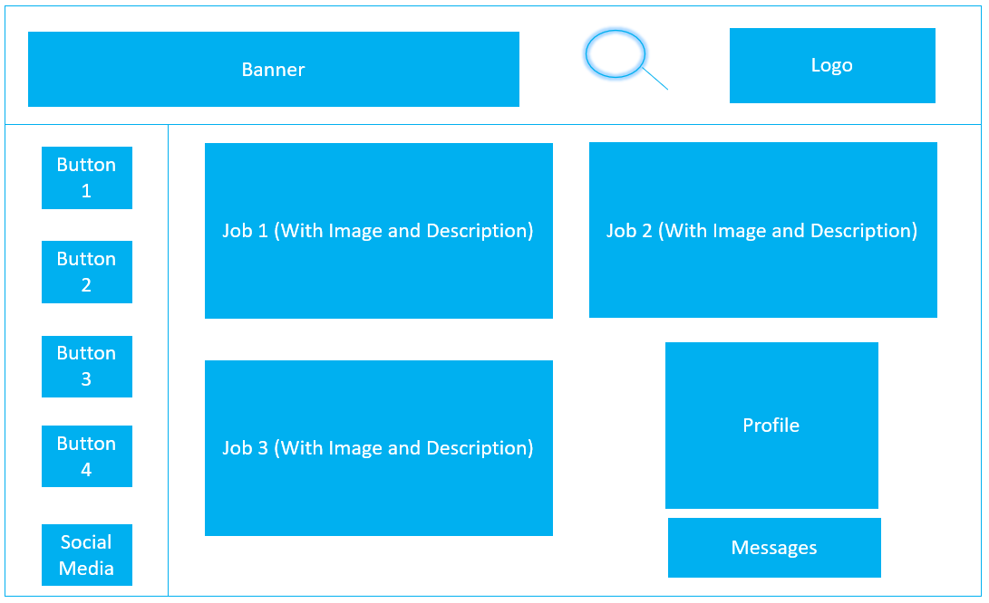**Initial Design 2:**

This design includes social media access along with a banner, and images with a brief description of other job presented.

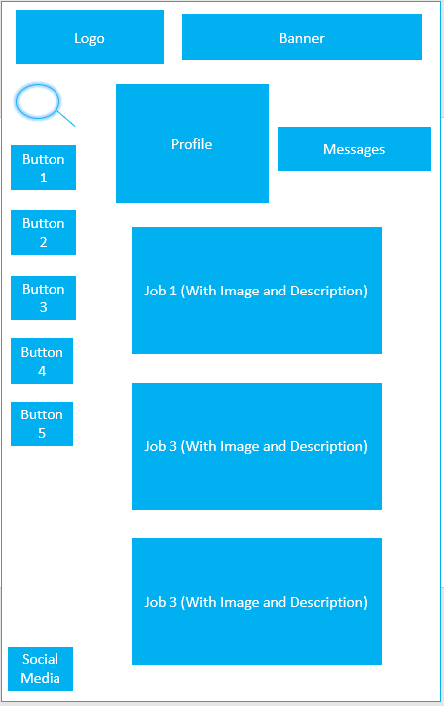**Initial Design 3:**

This design follows a vertical layout. It also eradicates most of the plain background and fills the page with content to keep the user engaged.

**Design Feedback**

After completing the 3 designs, I decided to receive feedback from 100 people to help me decide which design is the best. Here are the most popular answers:

|  |  |  |  |  |
| --- | --- | --- | --- | --- |
| Feedback Participant | Which Design is the most visually appealing? | Which Design do you dislike the most? | Which Design is the most functional? | Which Design do you personally prefer? |
| Target User (University Graduate) | 3 | 1 | 2 | 2 |
| Client (Hot Beans) | 2 | 1 | 2 | 3 |
| Colleague Designer | 2 | 1 | 3 | 2 |
| Member of the Public | 1 | 3 | 2 | 1 |

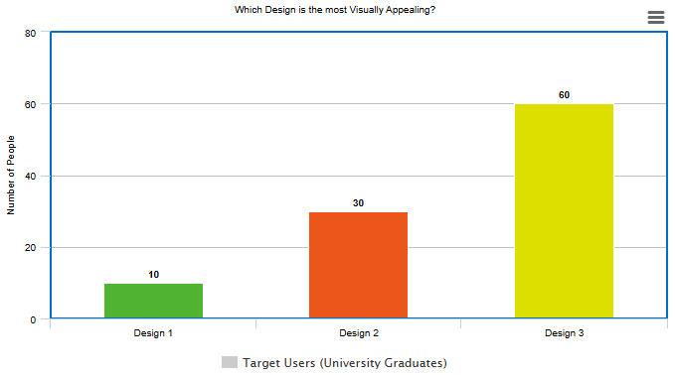

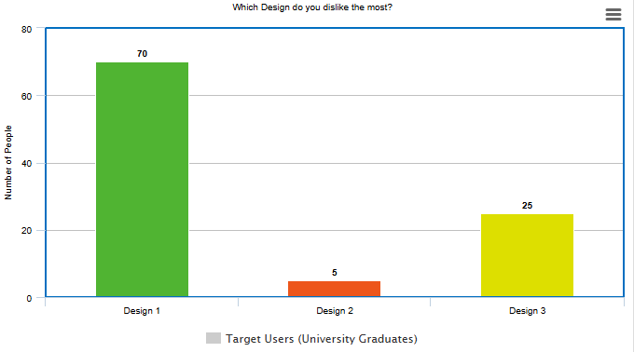

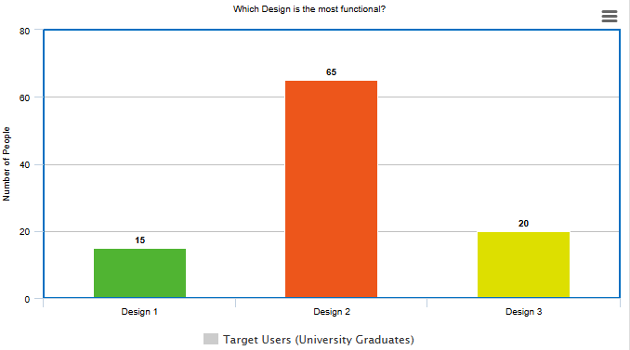

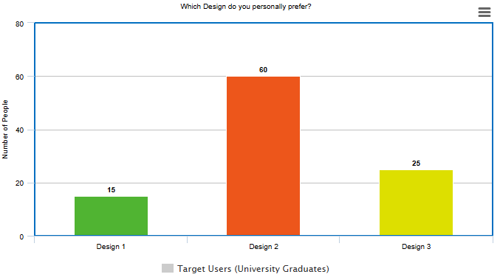

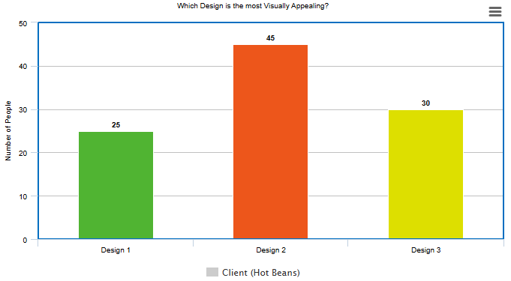

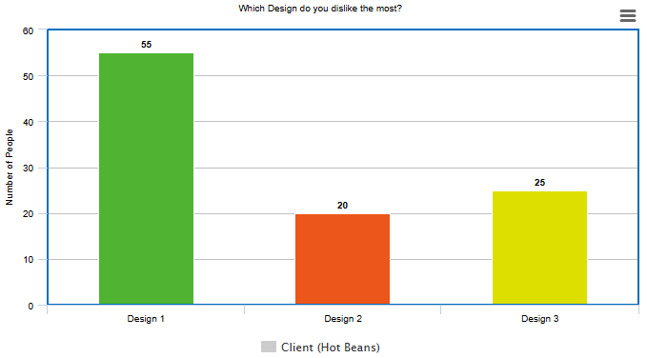

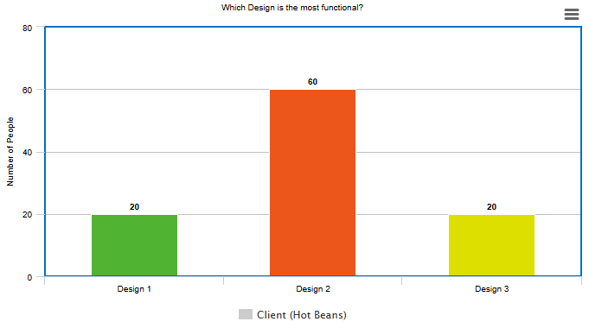

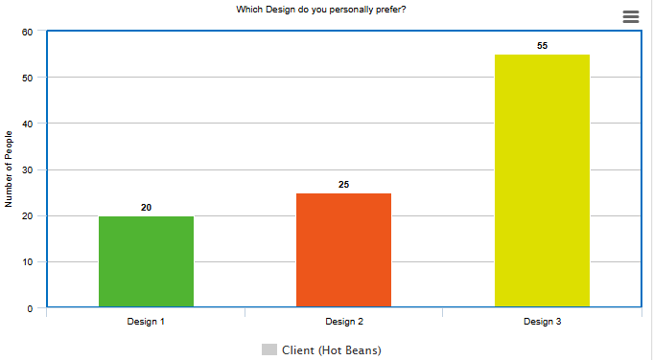

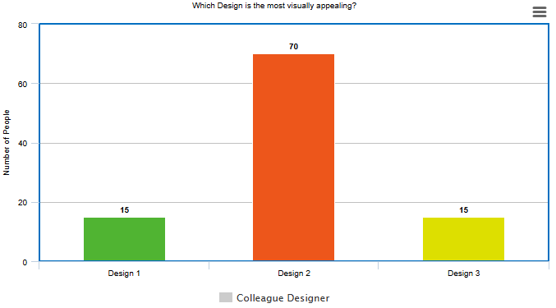

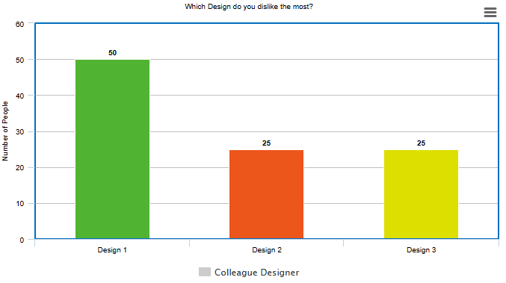

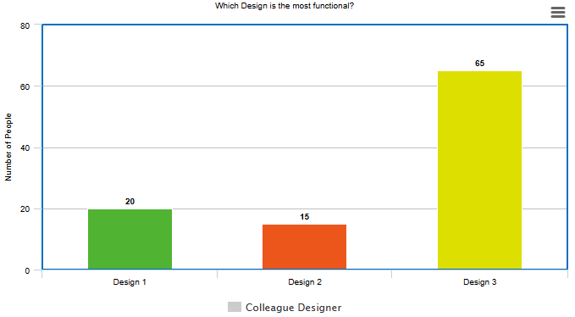

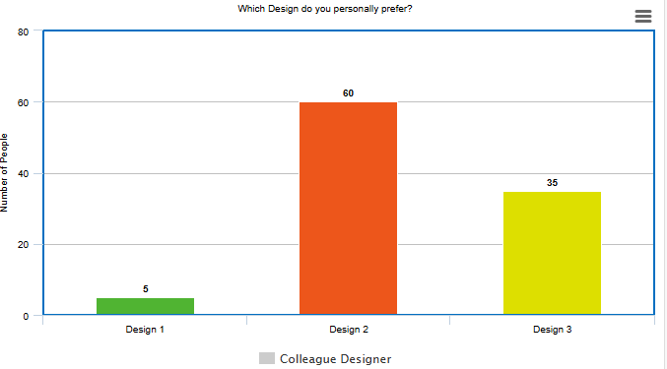

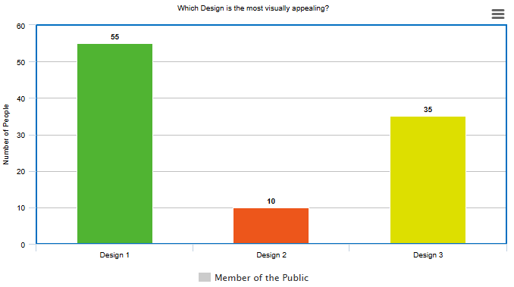

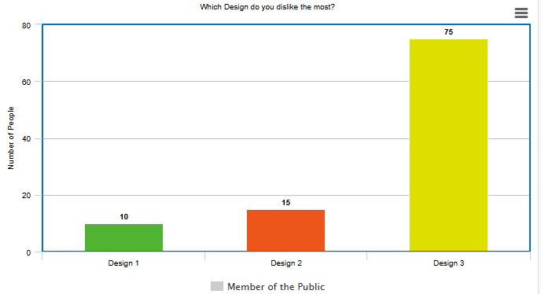

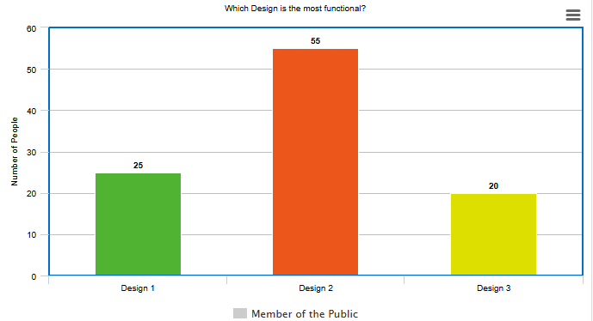

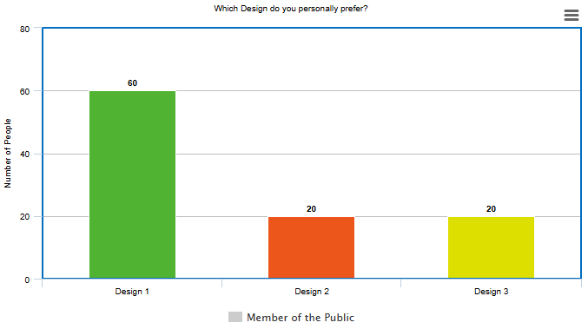

**Final Design**

Finally, after considering each design I have decided to go with design 2 as my final design. Having obtained client and user feedback, it was quite split between design 2 and 3, but personally I prefer design 2’s functionality and overall design slightly more than design 3. Furthermore, completing a horizontal styled website would be much easier to develop than a vertical website. In this design, I will have my banner at the top of the website, with a search bar and logo. On the left side will be my buttons, which will be rollover images that link to 4 different pages: About Us, Profiles, Jobs and Apply Now. About Us will take the user to a page that contains information about Hot Beans, with a message from the CEO about the founding of the website. Profiles will contain different employees’ profiles and summary about the job they currently have. Jobs will contain links and descriptions about courses and jobs for people to apply for. Apply Now will contain JavaScript forms that allows the user to enter their details and apply to a job. On this design, the most popular jobs will be present on the home page to attract users, along with a profile that users can make so companies have the chance to reach out to them.

**Requirements for an Interactive Website**

The website should meet all the design brief interactivity requirements and have additional interactive elements in order for it to be a good website.

**Gantt Chart**

I used a Gantt Chart as a guide the schedule and how long the project should take me. I kept to the Gantt Chart as close as possible. Some tasks were done shorter or longer than displayed but overall, the Gantt Chart supported my time management and allowed me to fit everything within time.

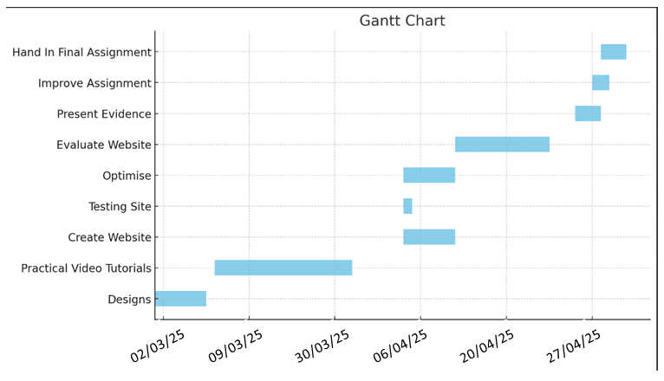

**Site Map**

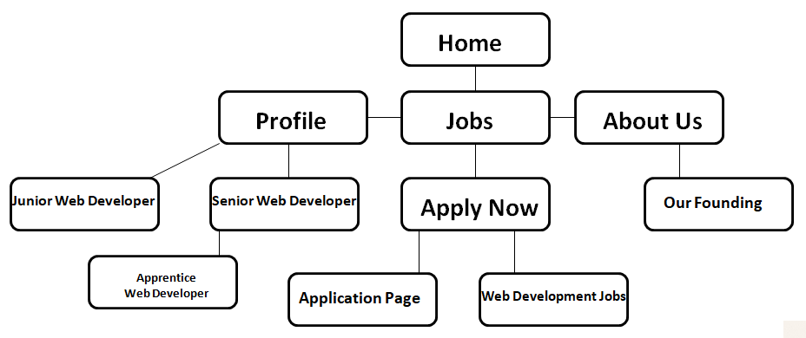

**Mood Board**

With a mood board for your event, you can collect ideas in your own style, organise them and share them with your co-organisers. The purpose of a mood board is to visualise a feeling, emotions, an atmosphere or ambiance. You can do that with words and with images.

Before designing the website, I will research 2 websites: BBC and Indeed to provide ideas for myself when designing the website, including: Visual Hierarchy, Contrast, Balance, Typography and User Experience.

**BBC**

The BBC website is known for its clean, user-friendly design. It follows a clear visual hierarchy, with important news stories or features placed prominently at the top using large headlines or images. The navigation menus are positioned at the top of the page for quick access. The most relevant content is prioritised, using size and colour to guide user attention. Headlines are often in bold, black text, and different shades are used to categorise different sections of the websites, for example categories of news. BBC has an amazing web design, shown through the popularity that comes from the high-quality user experience with the BBC website. For my website, I definitely want to use these principles of the BBC’s. I plan on doing this by categorising different industry of jobs with different shades to increase user experience and simplicity. Visual Hierarchy is used in almost every website, and I will be using it in mine in order to display jobs and profiles which are the most demanding on applications or on tight deadlines.

**Indeed**

Indeed also follows most of the same principles as BBC. As its purpose is to promote jobs and help people receive jobs, it must have a simple layout to prevent confusion for users, something which I must include for my website. Visual Hierarchy is present in this website. When opening the home page and making an account, you will be asked what type of jobs are for you and what area and pay you are after. Indeed will then provide the most relevant jobs. In this image, an apprentice plumber is being advertised, due to them hiring multiple candidates. On this website, the jobs that are most urgently needed will be promoted. Indeed’s website is primarily all white with black text. This increases the simplicity of the website to jobs as easy to find as possible. The text is clear and easily readable, along with easy-to-use buttons that take the user exactly where they need to be. The search bar is also very accurate, as whatever job title is entered is the jobs that will then be recommended. I am going to aim to use Indeed’s key principles to enhance my own website.

**Colour Palette**

With my website title being “Hot Beans”, my initial thoughts in terms of colours are a caramel / brown colour scheme with light text. This caramel / brown colour scheme links to the idea of cocoa beans and I believe it will be a visually appealing colour scheme that will attract users and increase their experience. With some websites just being plain white, it may leave the impression that not much development time has been put into it, but with mine that will not be the case. The contrast between the colour scheme and the light-coloured text will ensure that users can easily understand the text displayed and not have any confusion when reading. The colour caramel represents warmth, comfort, and indulgence, often associated with the cosiness of autumn and the sweetness of desserts. Psychologically, it evokes feelings of security and homeliness, making it an ideal choice for creating an inviting space. This is perfect for my website, as I want users to feel as comfortable and secure as possible when looking for jobs that may change their lives. Caramel colouring may be used to simulate the appearance of cocoa in baked goods, make meats and gravies look more attractive, and darken soft drinks and beer. As my website is called Hot Beans, the cocoa theme links to cocoa beans. Although my primary colour will consist of caramel, I will also include secondary colours such as black, white and grey, for things like labels, buttons and text to make them as clear as possible.

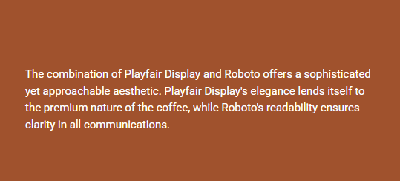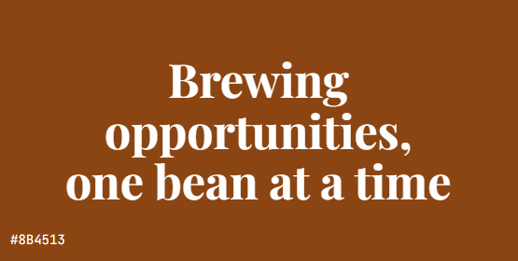

**Typography Choices**

Here are some possible fonts I would like to use:

Serifs are for traditional print, and Sans Serifs are for the web – it's not that black and white. Some Serif typefaces can look beautiful online, and you'll see many Sans-Serif fonts used effectively in printed material, books, and magazines. Screen resolution has changed, and the way we consume material has changed.

* Playfair Display
* Roboto
* Arial
* Helvetica
* Baskerville

**Final Mood Board Design**

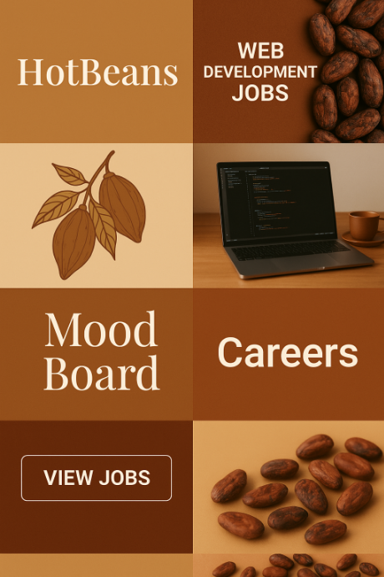

**Assets Table**

Here is a list of assets that I will add to my website, with a description of the asset.

|  |  |  |
| --- | --- | --- |
| **Asset** | **Description of Asset** | **Justification** |
| hot beanz.png | Website Banner - Hot Beans Banner which will be placed at the top of the home page | My Banner is the stand out asset in my website. It establishes the themes of the website along with purpose of the website. My colour choice was established in my mood board section. |
| Hot Beans Logo.PNG | Website Logo - Used as a constant logo throughout the website design | My logo was a very simple design, capturing the colours and title of the company. |
| search bar background.PNG | Search Bar Background - Provides the image of the search bar which will go in the background of the JavaScript Search Bar | This search bar background makes my website look for professional |
| About Us.png | Profile Button Image - When clicked will take the user to the Profile Page | My buttons match the background of the website and white text to stand out. |
| About Us-Rollover.png | Profile Rollover Button Image - When the Profiles image is being hovered over, the rollover image will appear with Profiles underlined | My rollover buttons contain the button text underlined, to provide user interaction. |
| Apply Now.png | Apply Now Button Image - When clicked will take the user to the Apply Now Page | My buttons match the background of the website and white text to stand out. |
| Apply Now-Rollover.png | Apply Now Rollover Button Image - When the Apply Now image is being hovered over, the rollover image will appear with Apply Now underlined | My rollover buttons contain the button text underlined, to provide user interaction. |
| Profile.png | About Us Button Image - When clicked will take the user to the About Us Page | My buttons match the background of the website and white text to stand out. |
| Profile-Rollover.png | About Us Rollover Button Image - When the About Us image is being hovered over, the rollover image will appear with About Us underlined | My rollover buttons contain the button text underlined, to provide user interaction. |
| Jobs.png | Jobs Button Image - When clicked will take the user to the Jobs Page | My buttons match the background of the website and white text to stand out. |
| Jobs-Rollover.png | Jobs Rollover Button Image - When the Jobs image is being hovered over, the rollover image will appear with Jobs underlined | My rollover buttons contain the button text underlined, to provide user interaction. |
|  | About Us Description – Description of Hot Beans on the About Us Page | My description for about us is white text with clear spacing, so the user can understand the text |
|  | Anna Norton Profile – Profile on the profile pages for Anna Norton. Contains information as well as an employee summary | My Anna Norton Profile has details on the left-hand side and profile picture on the right, with the about me in the middle as it is the most important. |
|  | Dark BG – Filler background to fill in white background | This asset is simply used to fill in white space, which improves readability, creates visual balance, and emphasizes key elements. |
|  | Caramel BG – Filler background to fill in white background | This asset is simply used to fill in white space, which improves readability, creates visual balance, and emphasizes key elements. |
|  | Hot Beans CEO – Image of the Hot Beans CEO on the about us page | My Hot Beans CEO profile picture is to help users to become familiar with the head of the company |
|  | Contact Us Button – Image that says contact us that appears on employee profiles | The contact us button gives the impression that users can interact with the employees at Hot Beans |
|  | Jobs Banner – Banner that appears at the top of the jobs page | This banner is to make clear what page the user is viewing |
|  | Jobs List – Appears on the jobs page which contains jobs. On the website, these will appear with web links which contain links to similar existing courses relevant | This asset has the titles of the jobs in the biggest font, as that is the most important aspect. The company and location are slightly smaller and the job description the smallest, going in hierarchal order |
|  | Light BG – Filler background to fill in white background | This asset is simply used to fill in white space, which improves readability, creates visual balance, and emphasizes key elements. |
|  | Rajesh Khanna Profile – Profile on the profile pages for Rajesh Khanna. Contains information as well as an employee summary | My Rajesh Khanna Profile has details on the left-hand side and profile picture on the right, with the about me in the middle as it is the most important. |
|  | Our Founding – Contains the summary of the founding on Hot Beans, alongside an image of the CEO | This asset helps users understand how the company was founded. It contains clear bold text for clarity. |
|  | Profiles Banner – Banner that appears at the top of the jobs page | This banner is to make clear what page the user is viewing |
|  | Ricardo Dos Santos Profile – Profile on the profile pages for Ricardo Dos Santos. Contains information as well as an employee summary | My Ricardo Dos Santos Profile has details on the left-hand side and profile picture on the right, with the about me in the middle as it is the most important. |
|  | Social Media – Buttons that show social media icons on the Home Page | Social icons will invite web guests to company's profiles where they could follow you and be aware of the latest offers, products and trends. |
|  | Jason Cunha Profile – Profile on the profile pages for Jason Cunha. Contains information as well as an employee summary | My Jason Cunha Profile has details on the left-hand side and profile picture on the right, with the about me in the middle as it is the most important. |

**Search Engine Optimisation**

Search Engine Optimisation is the process that attempts to improve search rankings or how something is searched for. Hot Beans can improve its search rankings by using keywords that a target audience may be looking for. E.g., Web Developer Job, Junior Web Developer, Graduate Website Jobs etc.

**Design Decisions Justification, how they will meet the Users' Needs and be Fit for Purpose**

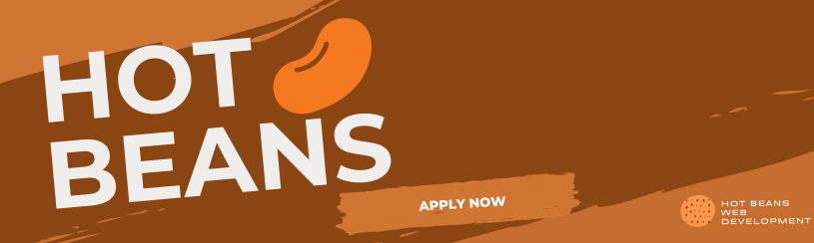I will now proceed to justify the design of my assets. Firstly, the high majority of my assets were designed by myself on the graphic design software Canva. My first design was my banner that will appear at the top of the home page. The purpose of a banner is to capture a user's attention, while also capturing the theme of the website. A website banner is to create a focus point to be the first thing noticed. It is critical to get a banner right as it only has mere seconds to capture the interest of a user for further browsing. In order to retain user retention, I added labels such as "Apply Now" and "Hot Beans Web Development" in order to establish the purpose and the developers on the website.

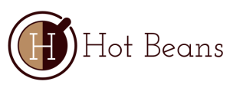My Hot Beans Logo was created using a logo maker on the internet. The logo is not infringing watermarks or copyright. I decided to go with this logo as it is simple and contains the colours of the theme of the website. It meets the users' needs by creating identification for the website, increasing popularity

My Buttons are simple, containing the same colour as the light caramel part of the banner. This keeps a consistent theme going throughout the website. The buttons also include rollover images, giving the illusion that button is changing when hovered over. This is a nice touch and adds a professional aspect to the website.

Another design decision was to add work profiles from employees currently working for Hot Beans, in order to provide high expectations for graduates looking for jobs.

I also designed jobs and job descriptions on my home page and jobs page. On the home page, I decided to make a slider containing 3 popular jobs that people could look at. I made the slider for the home page as the purpose of a home page is to navigate users to other parts of the website. If I allowed users to look at the job in detail, there would be no need for the other pages. The jobs page includes job descriptions designed by myself in Canva, with the Job Title, Salary and Location, and then description all in hierarchal size order, with title the biggest and description the smallest. The decision for this design is to emphasise the title that people are applying for so users don't accidentally apply for the wrong job. Description is the smallest as it just includes extra's about the job and what it includes, which graduates who are applying will know anyway. The jobs also contain links corresponding to courses similar to the job being advertised. This decision is to help users' who want to know exactly what the job includes understand what's included at Hot Beans.

Overall, I believe I my design decisions will meet the users' needs and fit the purpose of the website. The colour scheme and placement will engage the user, providing an enjoyable navigation.

**Technical and Design Constraints**

When working on designing a website, there are constraints which need to be identified and taken into account.

The first constraint is time. I have a deadline which needs to be stuck and will be managed by sticking to my Gantt Chart Plan.

Next, I have Legal and Ethical considerations which need to be applied to the equivalent legislation in the United Kingdom, which include:

* **The Data Protection Act 1998 -** This law outlines how personal data about individuals should be collected, stored, and used legally. Its main purpose is to protect people from their information being misused or mishandled. It ensures that organisations keep personal data safe and private. I will make sure this law is followed at all times
* **The Computer Misuse Act 1990 -** This act was created by the UK government to prevent unauthorised access to computer systems. It helps combat issues like hacking and cyber-attacks. The law ensures that computer systems are protected from threats such as viruses and malicious software. I will make sure the website is secure and free from any harmful websites
* **The Copyright Designs and Patents Act 1998 -** This law gives authors, artists, musicians, software developers and other creators the legal right to control how their original work is used by others. It protects things like software, images, and other digital media from being copied or used without permission. The purpose is to make sure no one falsely claims someone else's work as their own. To follow this law when finding images for my website, I will use Google's search tools and personal designs from Canva to only choose images that are marked for non-commercial reuse.

**Web Development (Dreamweaver)**

**Steps to Creating to the Website**

Now I have carefully planned and designed what the website layout will look like and the assets will contain. I will create the website. The steps to creating the website include:

1. Create a Home Page with a layout banner, navigation bar, multiple buttons and images, and a slider containing jobs
2. Insert logo and header
3. 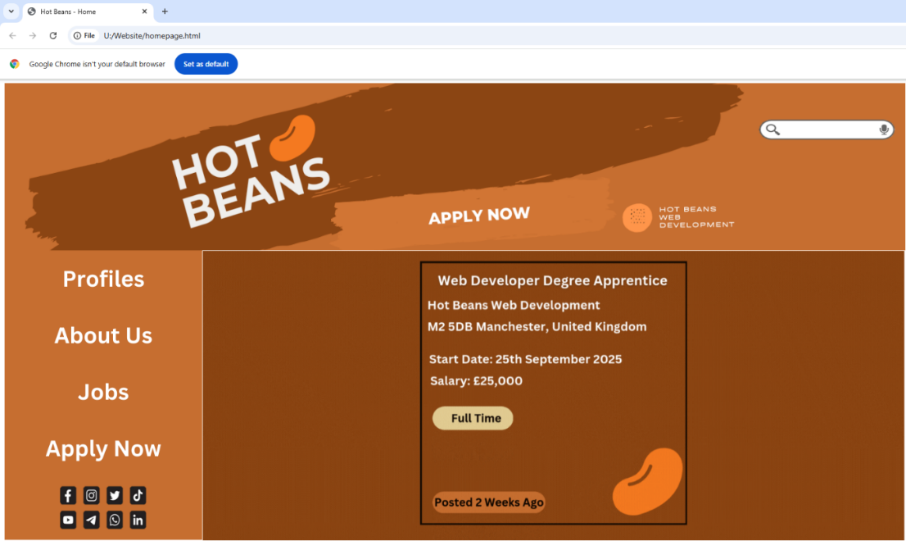Design my buttons with the same colour scheme as my banner
4. Create a slider with animations containing 3 different jobs
5. Use tables in Dreamweaver to create sections where I can insert my assets for the home page
6. I created the title of the web page as “Hot Beans – Home”

My Home Page looks like this:

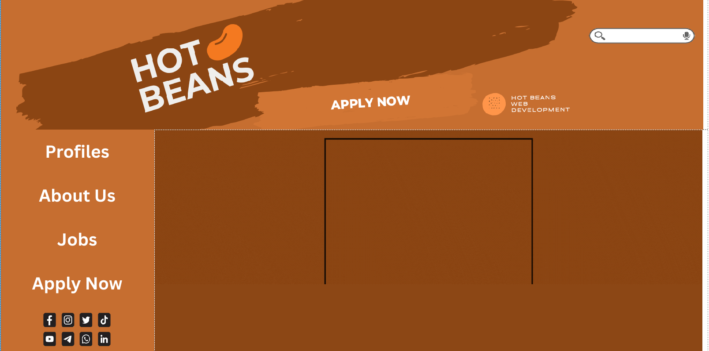

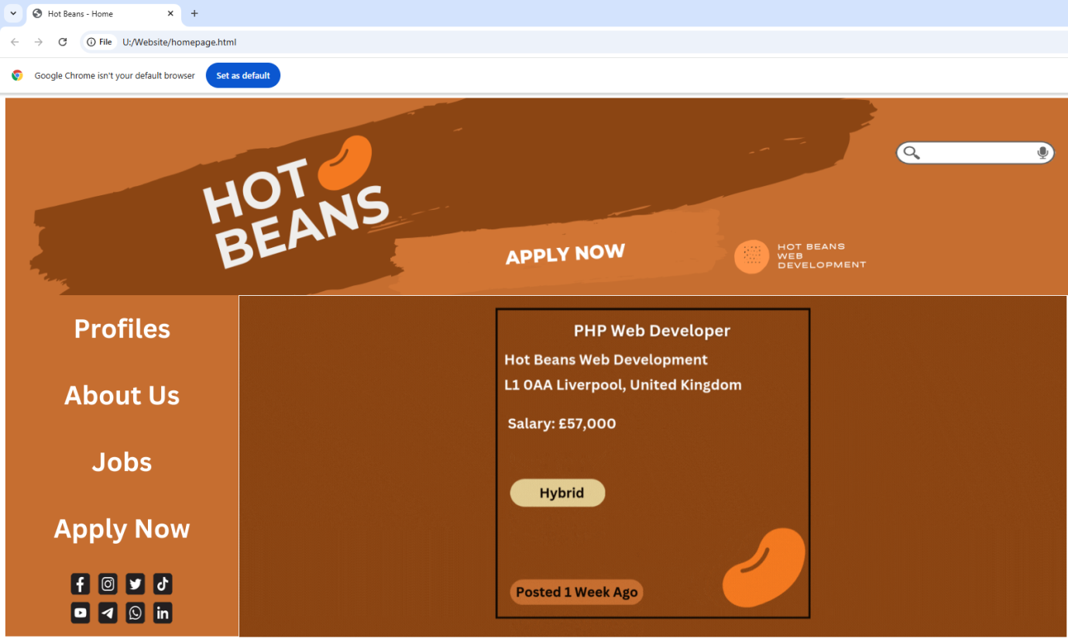

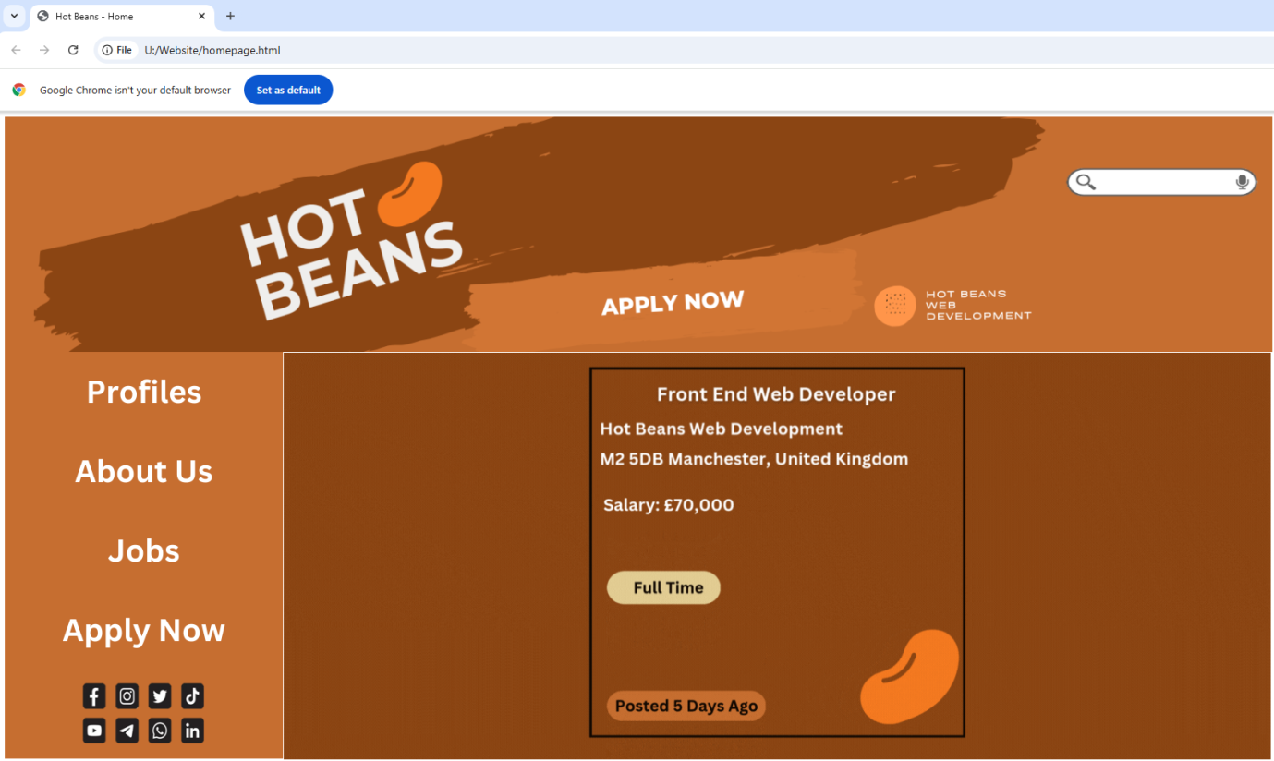

1. About Us Page – inserted 2 bodies of text including an overview of the company as well us Our Founding, with hyperlinks to the team

My About Us Page looks like this:

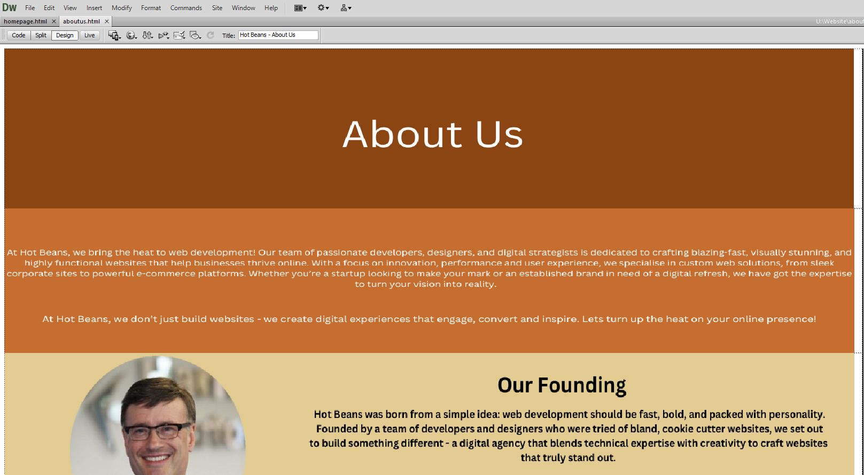

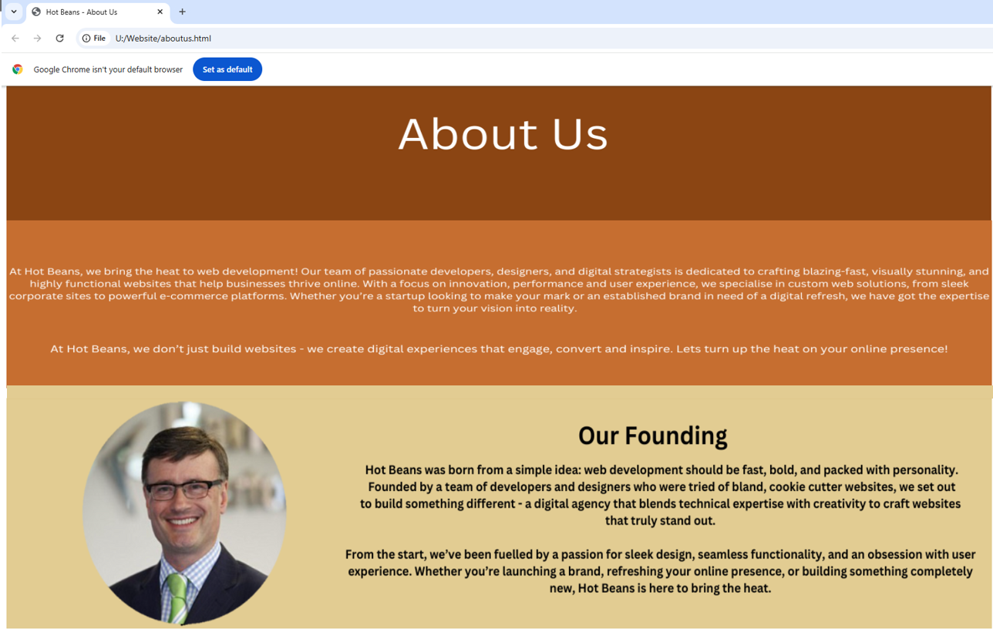

1. Profiles Page – inserted 4 Hot Beans employee profiles containing their name, year, location of employment, a description about them, and a profile picture.

My Profiles Page looks like this:

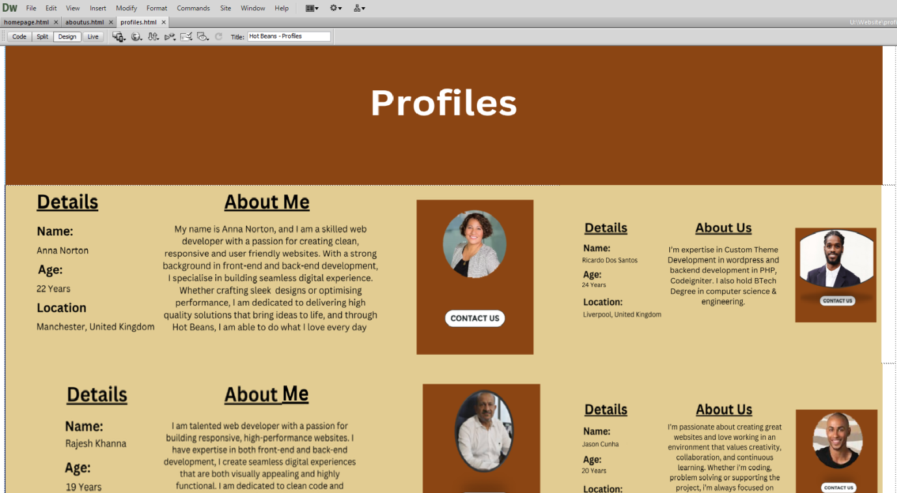

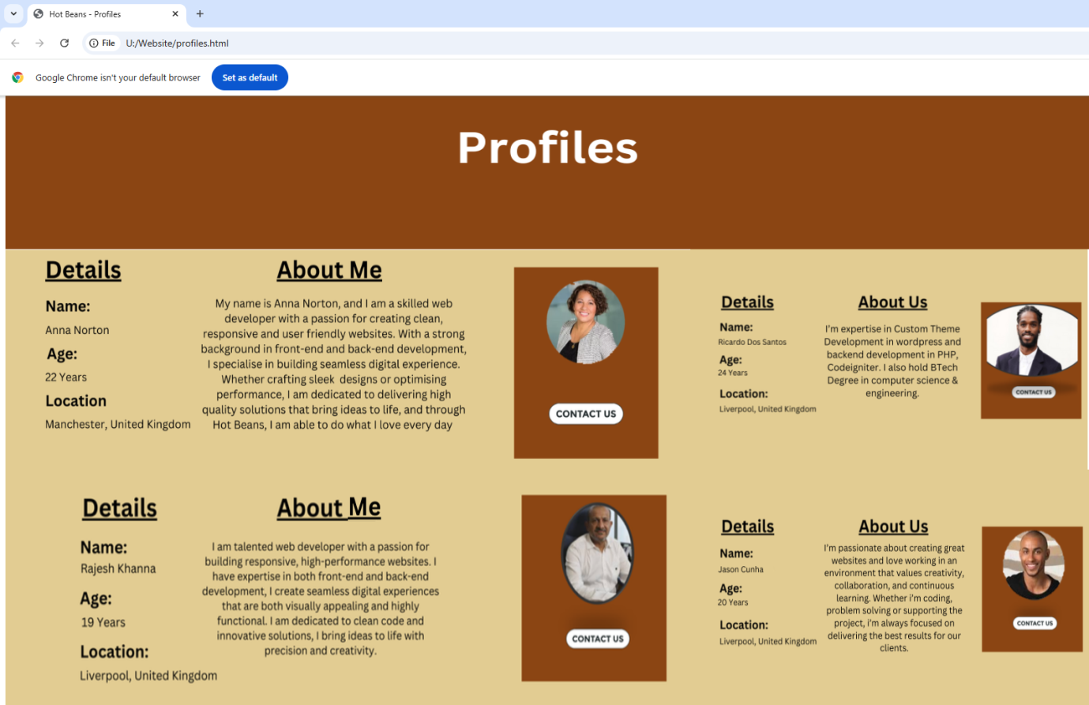

1. Jobs Page – inserts 2 jobs which are in detail with lots of information about the job, along with the basic information such as location and salary. This page will come with buttons with hyperlinks which take the user to existing similar job roles to understand the role

My Job Page looks like this:

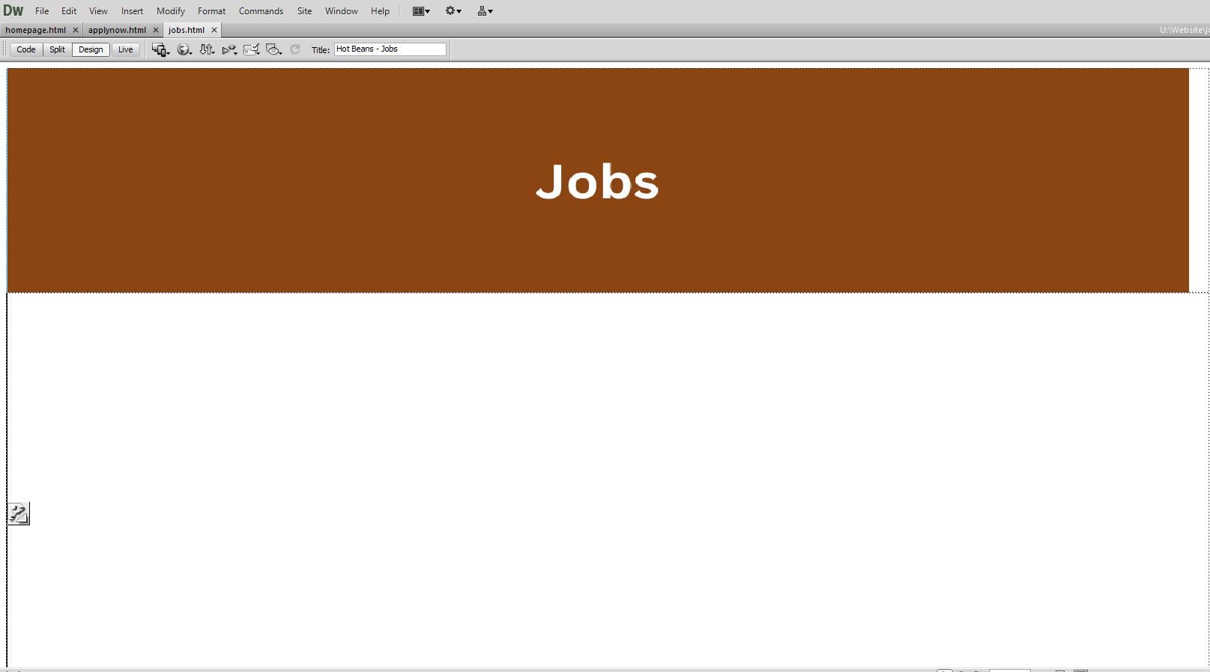

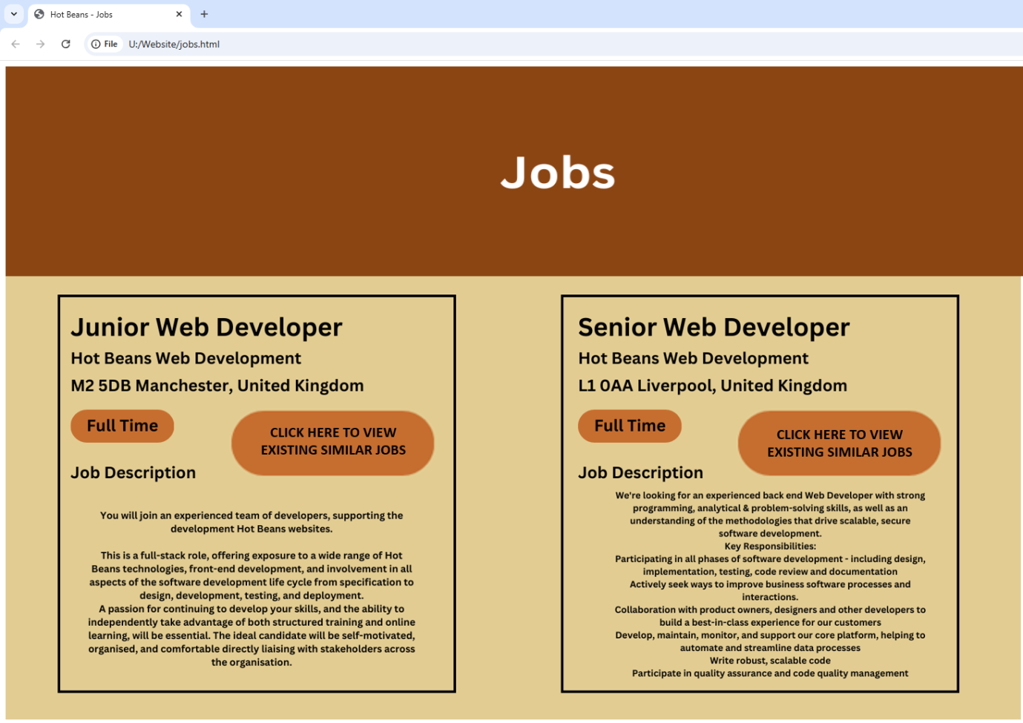

When the “Click Here to view existing similar jobs” is clicked, the user is taken to existing similar jobs to look at what the job includes.

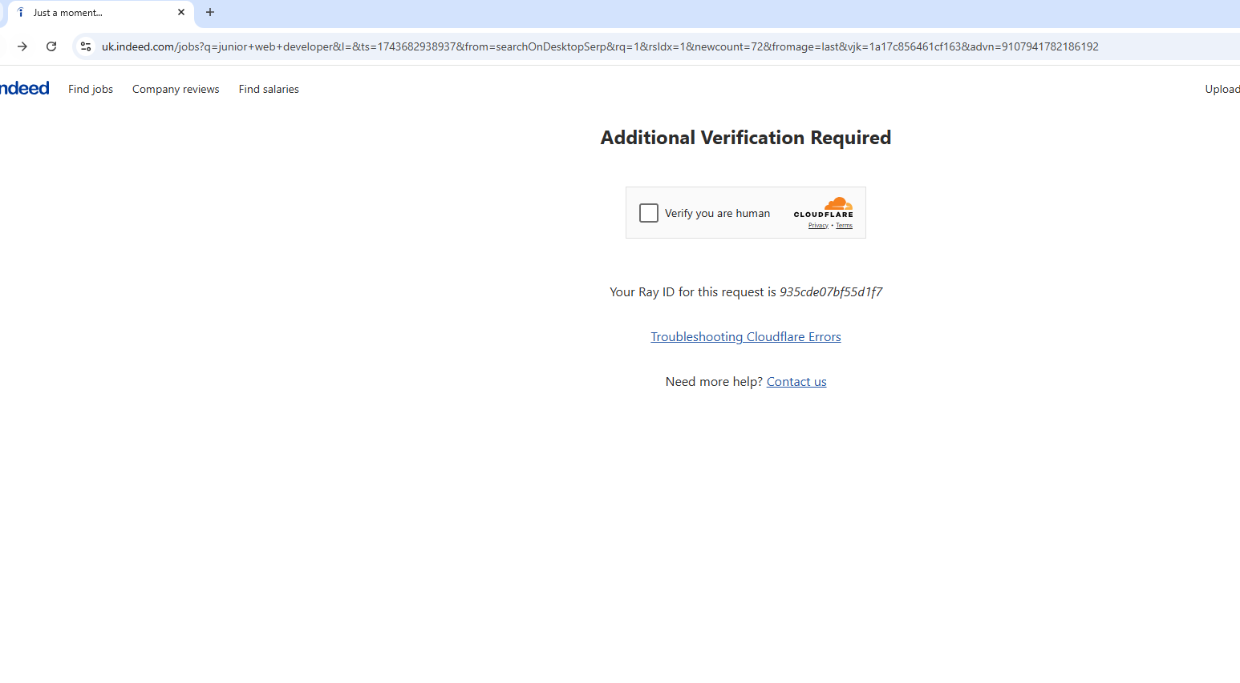

The user is then taken to a page where they can look at existing similar jobs.

1. Apply Now Page – inserted a job application with JavaScript Forms which allow the user to enter their details, such as name, address, job and CV. The application comes with a submit button to enter the details

My Apply Now Page looks like this:

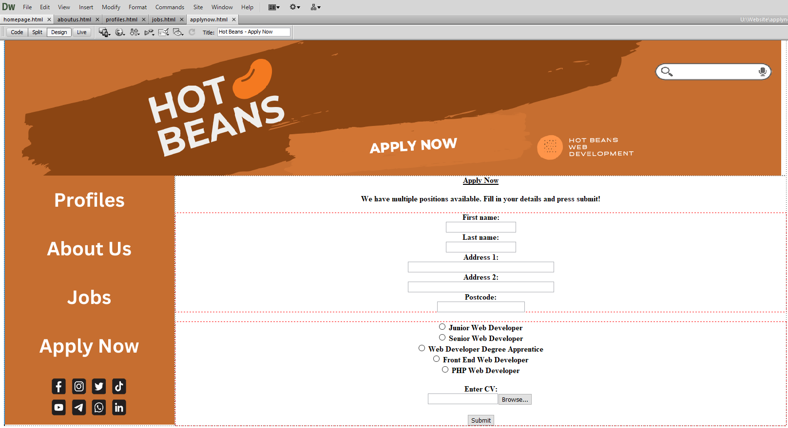

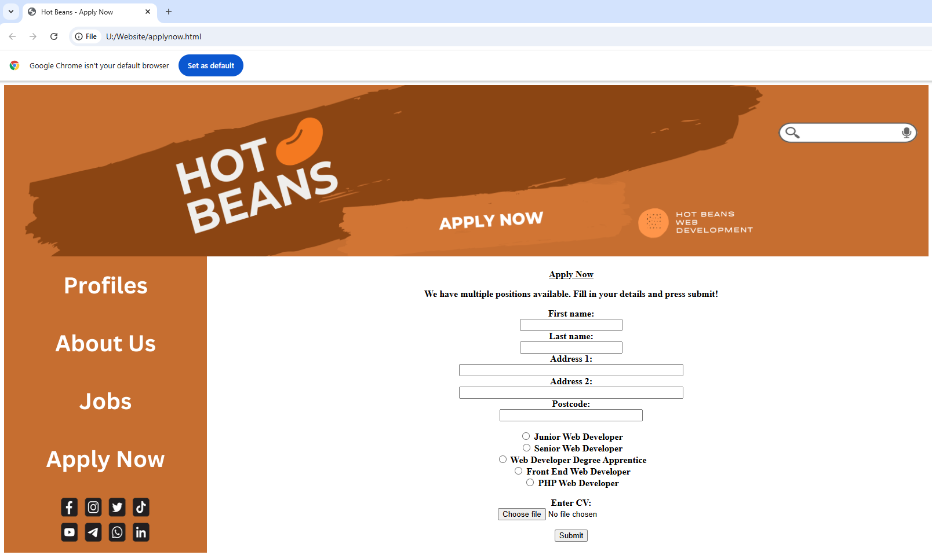

Users can fill in the application form with their details:  
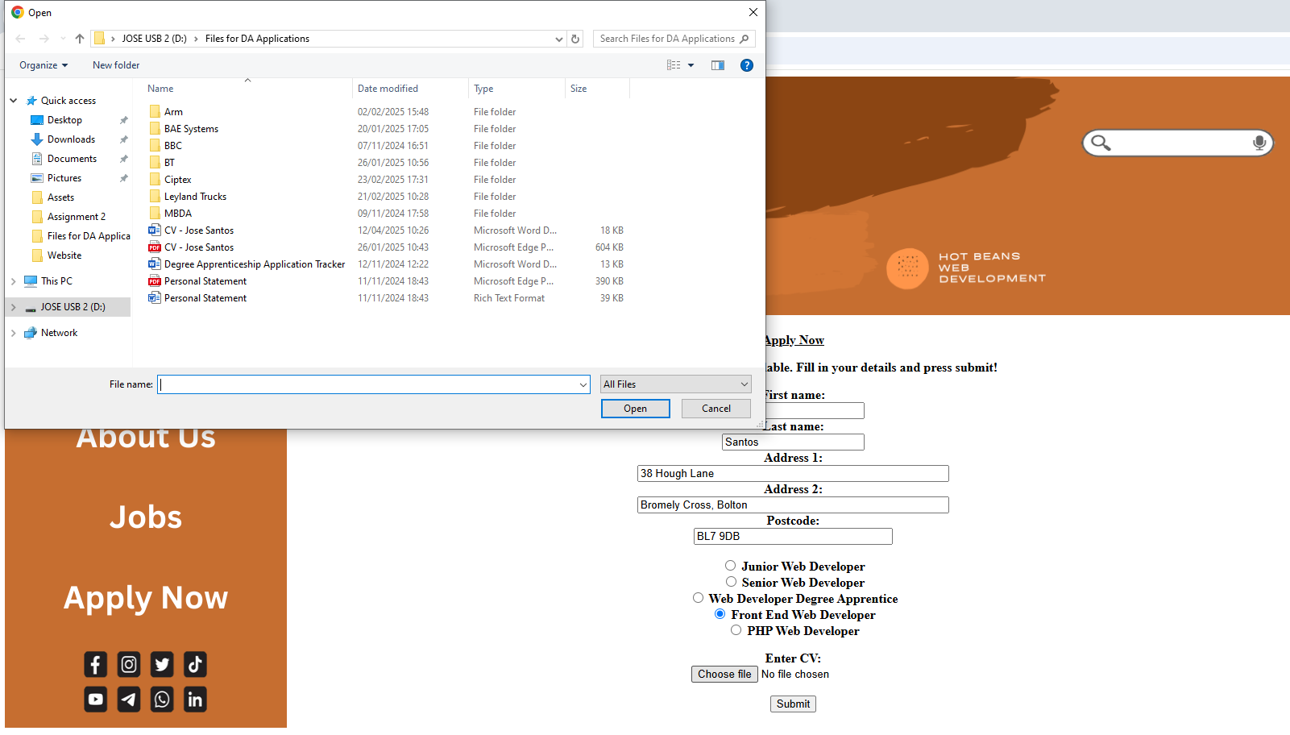

When CV is clicked, file explorer opens to allow the user to select a file.

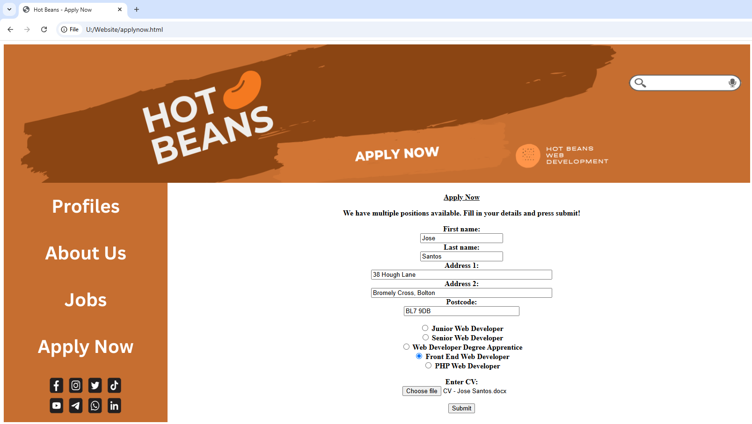

1. Application Confirmation Page – A Simple page that tells the user that their application went through and is being reviewed

When submit is clicked after the user fills in their details, the user is directed through the button click

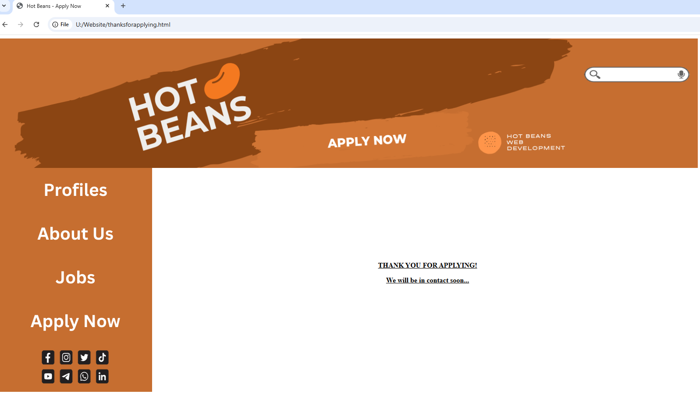



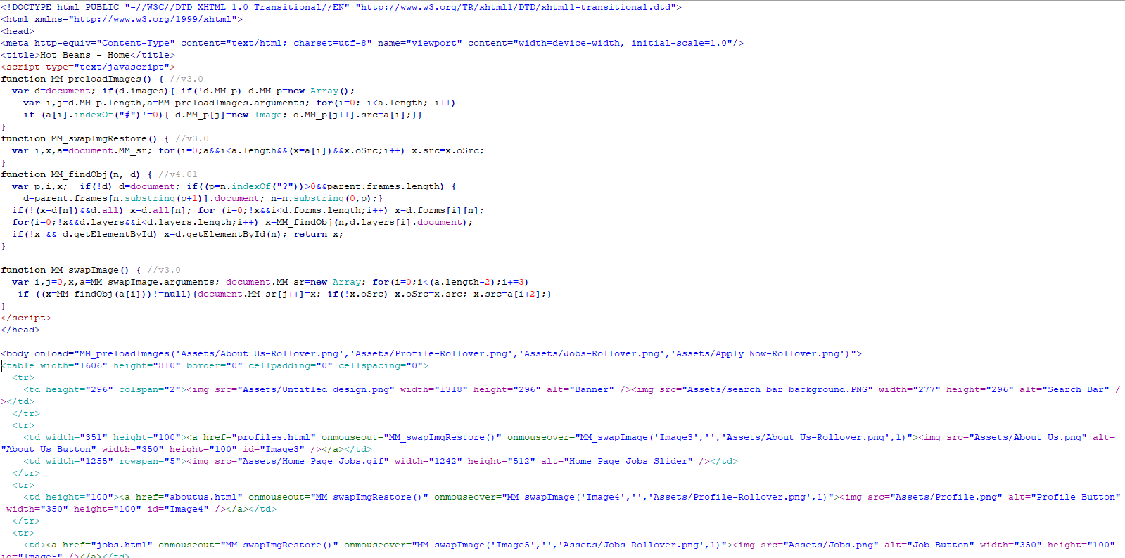**Home Page Code**

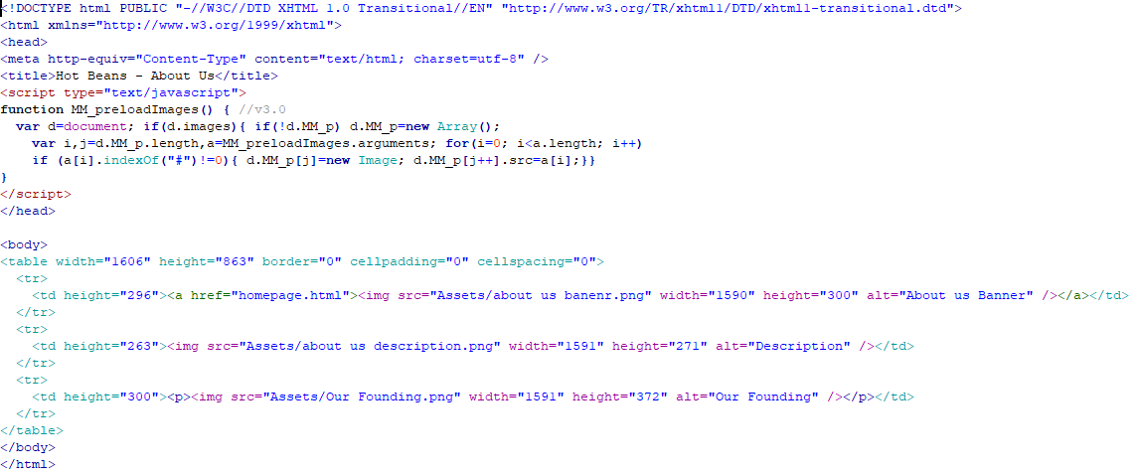**About Us Code**

**Profiles Code**

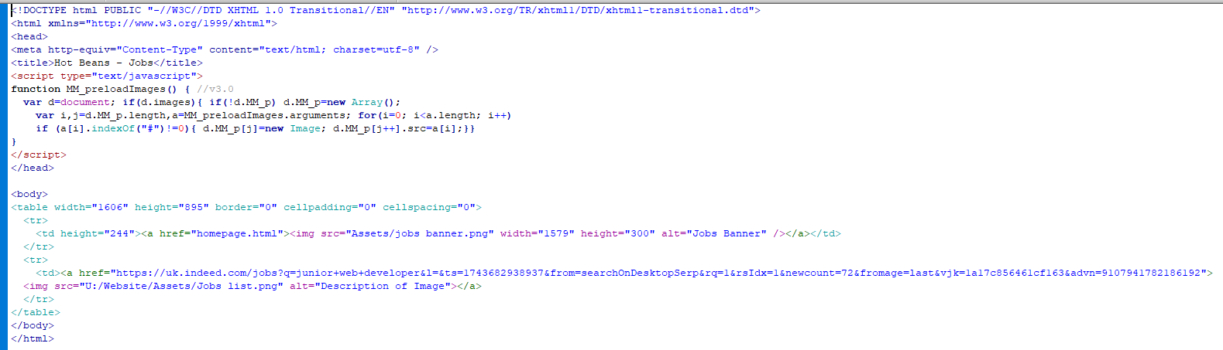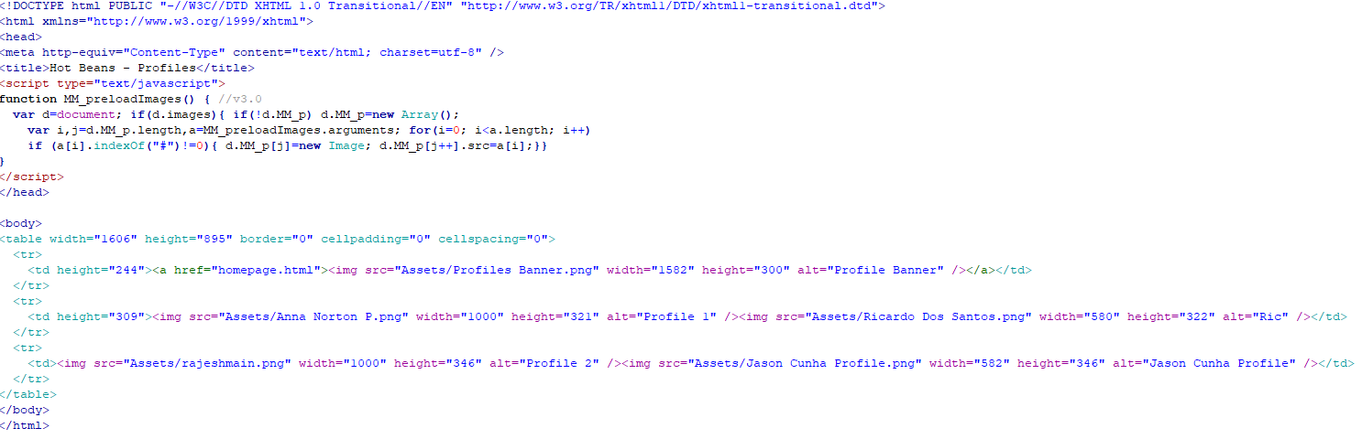**Jobs Code**

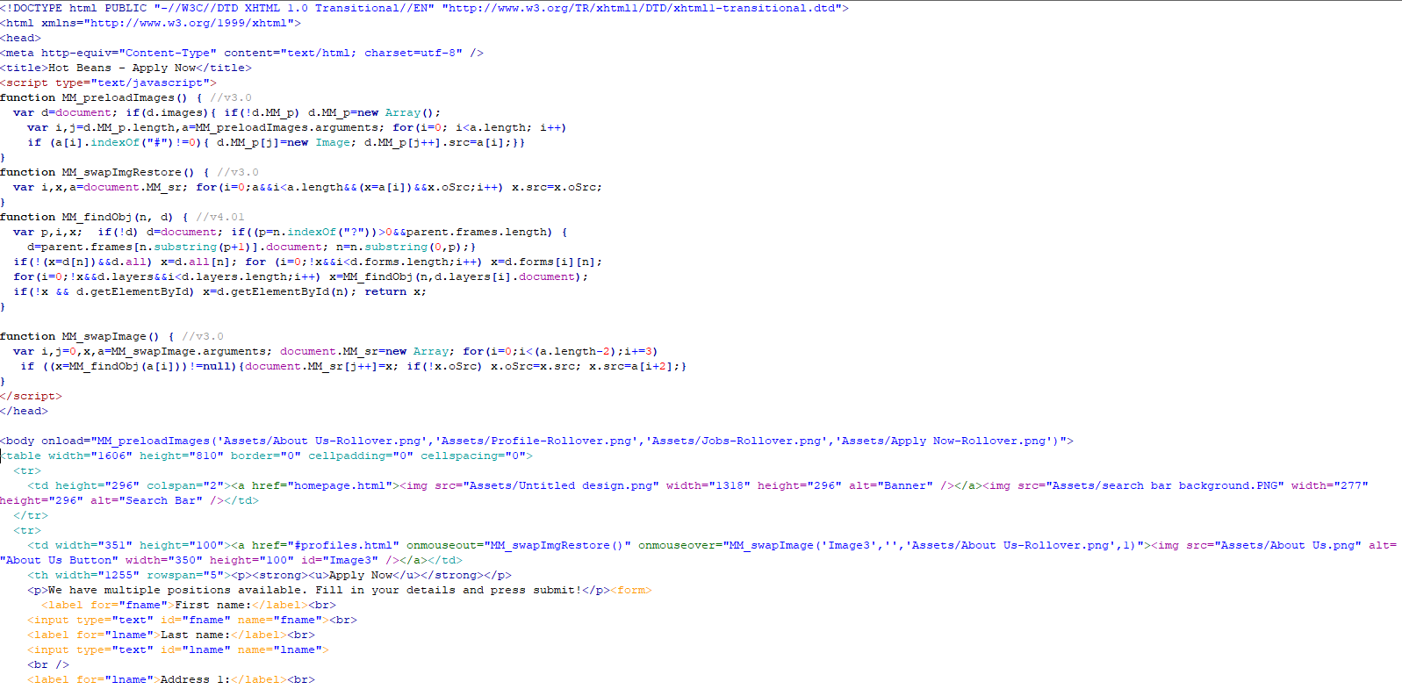**Apply Now Code**

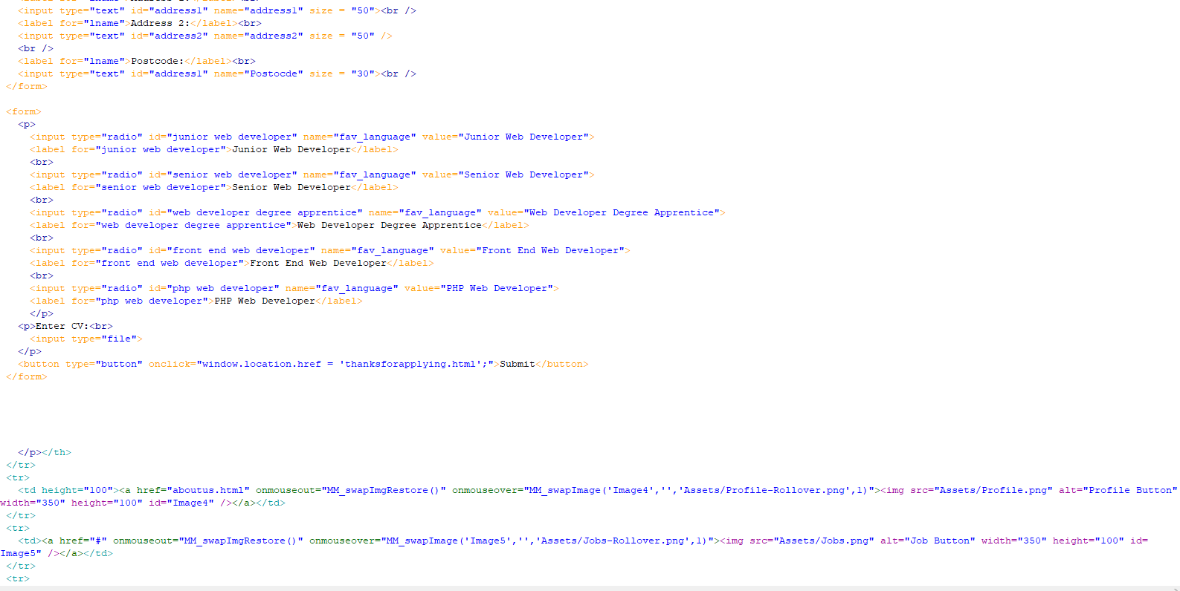

**Testing and Review**

**Testing**

Once the website was fully developed, I tested it using a WebTest Application, obtaining user feedback and then optimising the website.

When the results from testing the website came in, it gave me the results in 3 different categories: Is the website quick?, Is the website usable? and is the website resilient?

Starting with the tests to check if the website is quick, the Webpage Test ran 11 diagnostic checks related to this category and found 0 opportunities for corrections. This is perfect, meaning the website runs as the fastest capabilities it can.

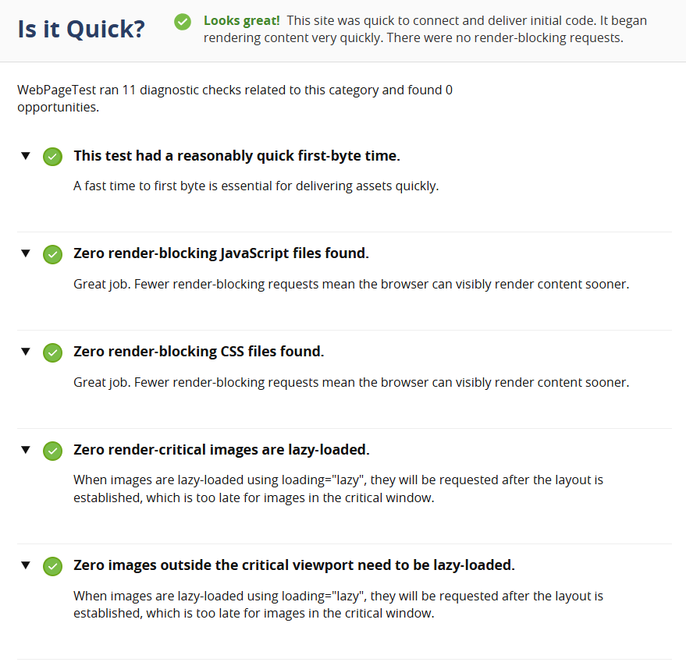

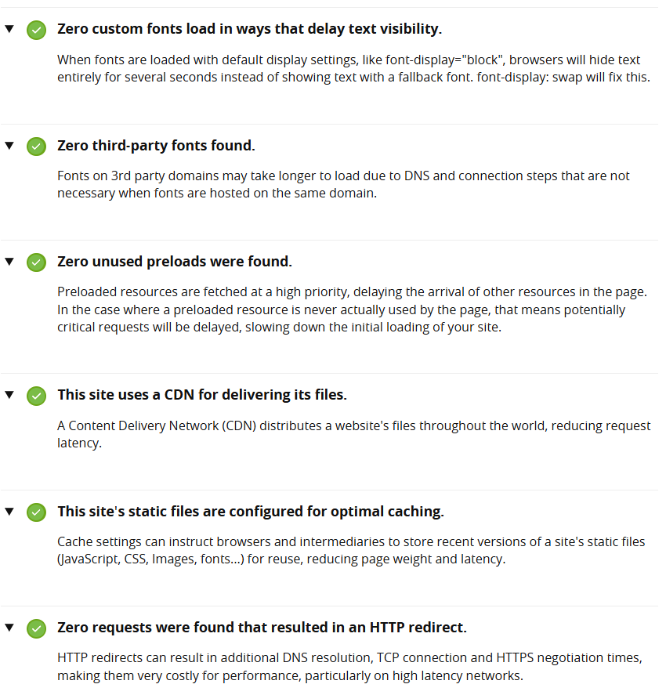

However, for the usable tests, I received one accessibility issue: Zooming and Scaling must not be disabled. This will prevent those with visual impairments to see the website clearer. This is an important fix as allowing zooming is essential for users with low vision who may rely on pitch-to-zoom or browser zoom features to read content comfortably.

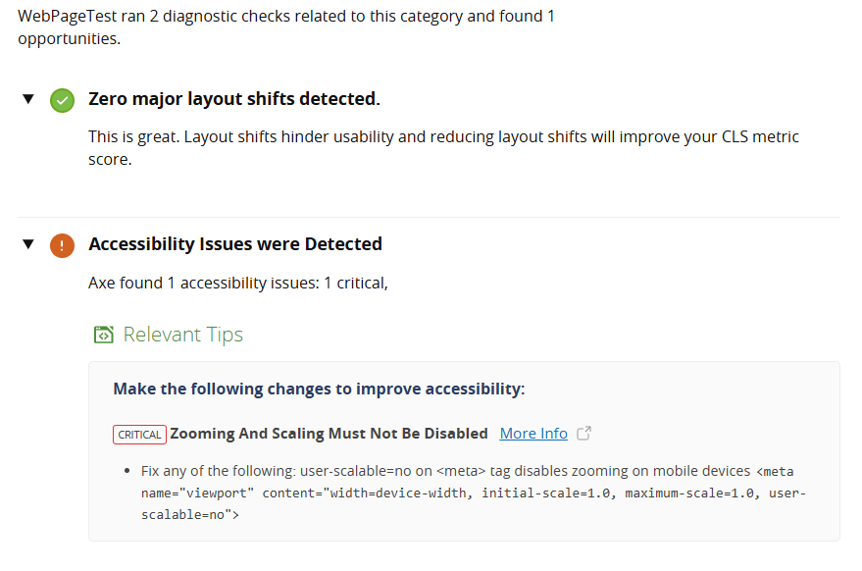

However, this was quite an easy fix, as I just added this line of code to allow zooming in:



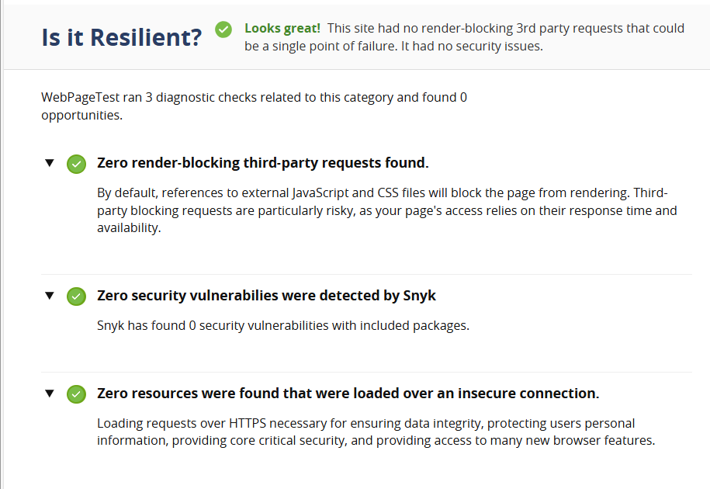In terms of resilient use, there were no errors.

**Testing Table: Functionality**

|  |  |  |  |  |  |  |
| --- | --- | --- | --- | --- | --- | --- |
| Feedback Participant | Do the Hyperlinks work? | Do the page links work? | Do the Rollover / Slideshow images work? | Does the Social Media icons link to the correct sites? | Do the forms work and submit with a confirmation page? | Is there a way to go to back? |
| Target User (University Graduate) | Yes | Yes | Yes | No | Yes | Yes |
| Client (Hot Beans Manager) | Yes | Yes | Yes | No | Yes | Yes |
| Colleague Designer | Yes | Yes | Yes | No | Yes | Yes |
| Member of the Public | Yes | Yes | Yes | No | Yes | Yes |
| Me (Web Developer) | Yes | Yes | Yes | No | Yes | Yes |

**Testing Table: Compatibility / Usability**

|  |  |  |  |  |
| --- | --- | --- | --- | --- |
| Feedback Participant | Does the Website function on a mobile and tablet? | Out of 10 – how usable is the website? | Is the website compatible on various browsers? | How easy is the website to use? (1-10) |
| Target User (University Graduate) | Yes | 8 | Yes | 8 |
| Client (Hot Beans Manager) | Yes | 9 | Yes | 7 |
| Colleague Designer | Yes | 7 | Yes | 9 |
| Member of the Public | Yes | 8 | Yes | 7 |
| Me (Web Developer) | Yes | 9 | Yes | 8 |

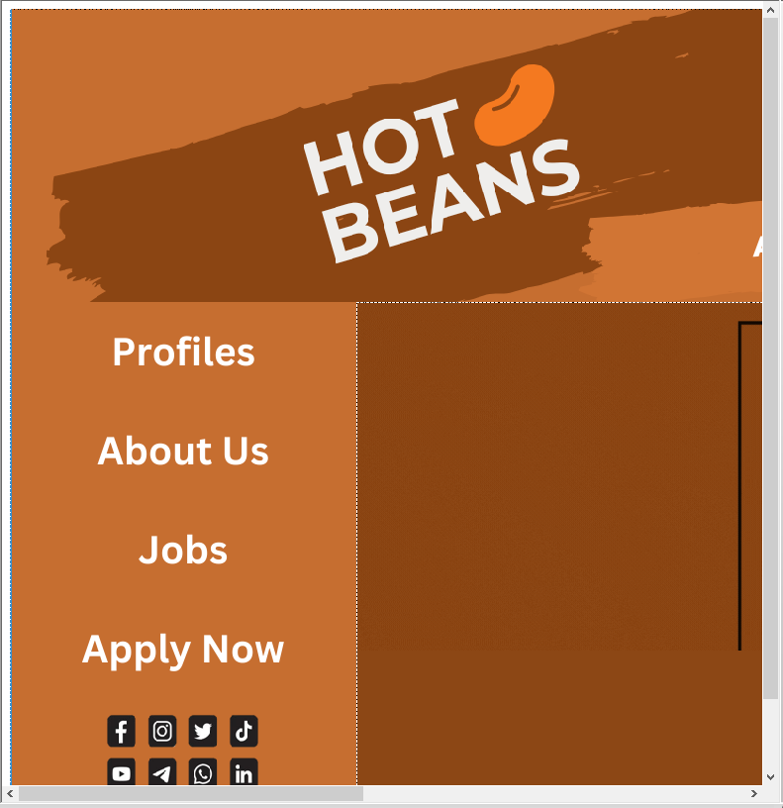**Collect Results / Feedback**

I’ve now tested the website for functionality, compatibility and usability and have 5 individuals test the website and record the results in the two test tables above. Overall, the feedback was positive, with every feature of the website working.

(Compatible with mobile, users will just have to use sliders to navigate)

However, when I was testing the website for bugs and errors, I found a few issues:

* White Space Design Issue – Website layout breaks, leaving white space between assets
* JavaScript Validation – Forms don’t validate properly
* Unoptimized Images – Images are larger than needed, slowing the page down

The 3 Main Problems will be solved below in the optimisation stage of the website.

**Optimisation**

**Optimise Website using Results of Testing and User Feedback recording Details of Changes Made**

The first error / bug that I encountered was a white space issue. On my About Us Page, there are 3 main assets that are present on this page: the banner, the overall description, and Our Founding. In between the overall description and Our Founding, there was a white space gap when running in the explorer browser, even though that gap did not appear in Dreamweaver.

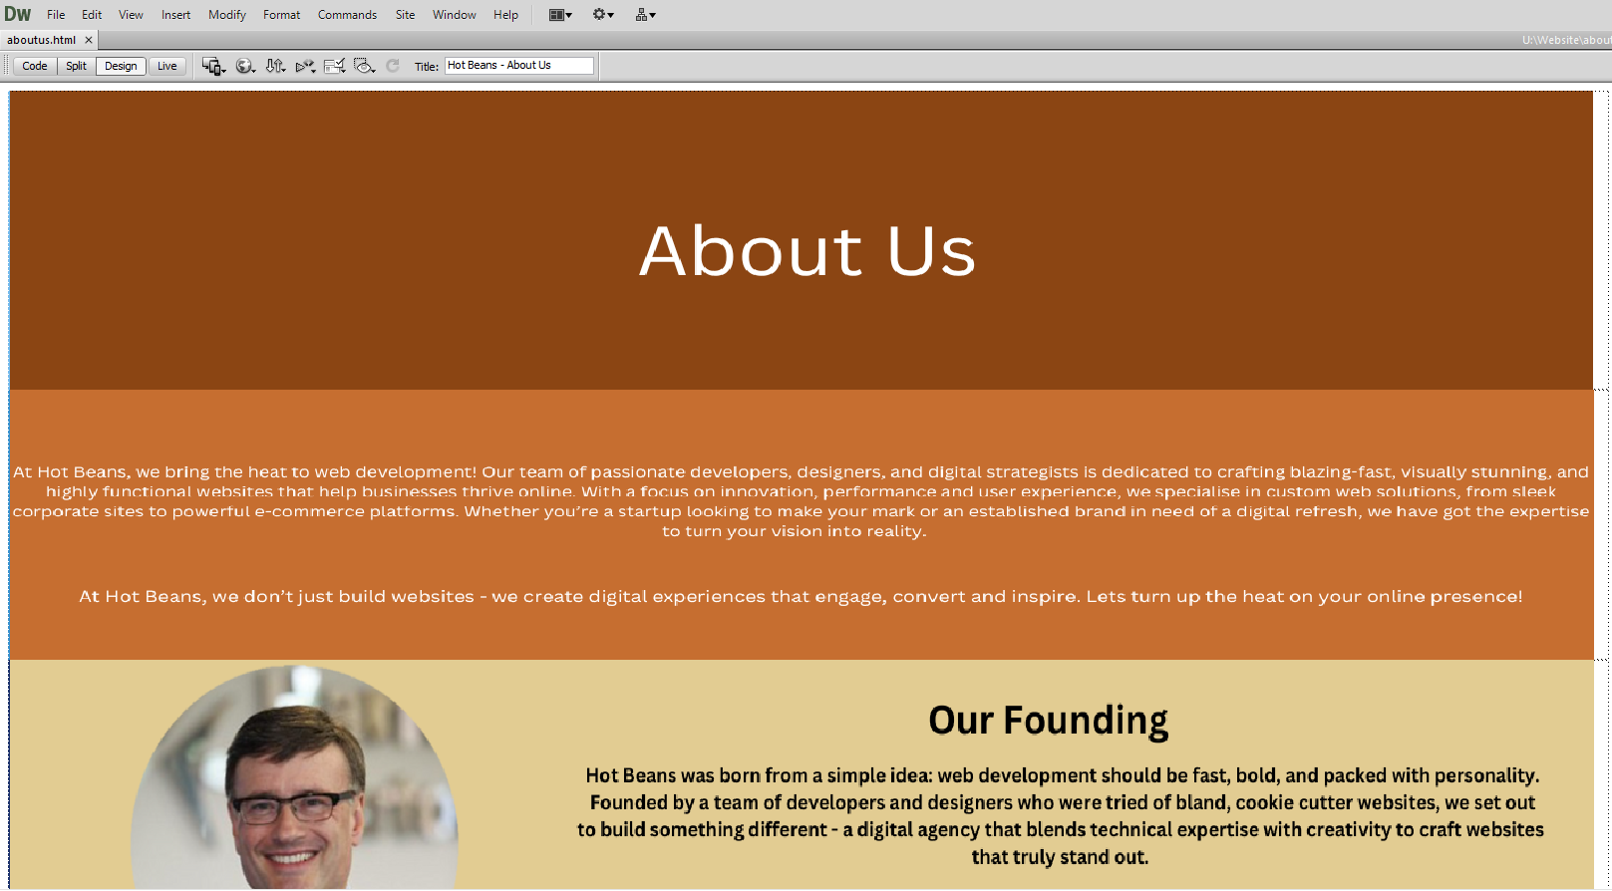

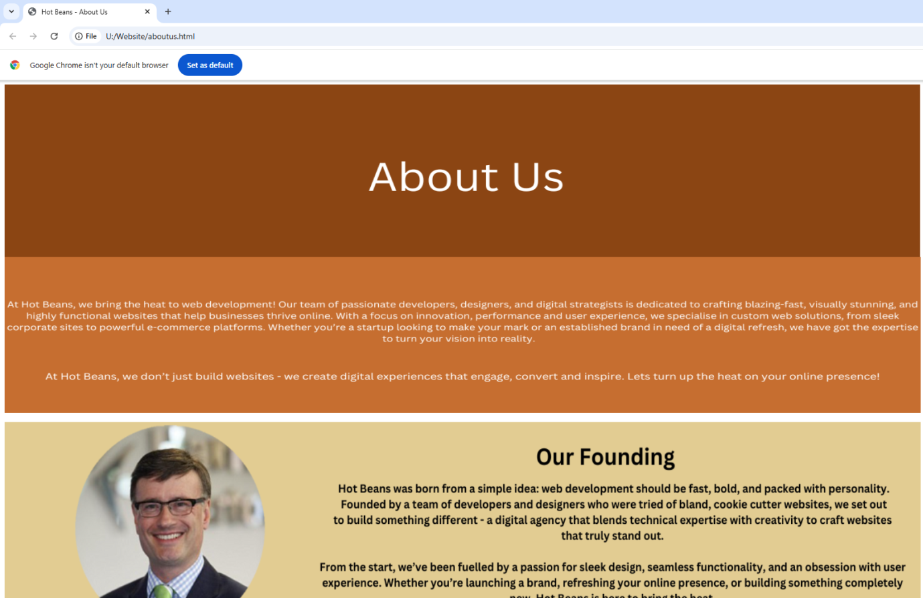

This issue was due to unwanted top margin or padding on the section, or an empty block element above it pushing the content down. To fix the issue, I inspected the element using browser DevTools and removed the top margin on the section. Using this CSS code, I fixed the issue.

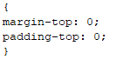

The result looked like this:



The second error / bug that I encountered was the lack of JavaScript Validation for my apply now forms. To add validation to my Apply Now Form, I used the HTML5 Form Validation, an easy and built-in way of adding validation.

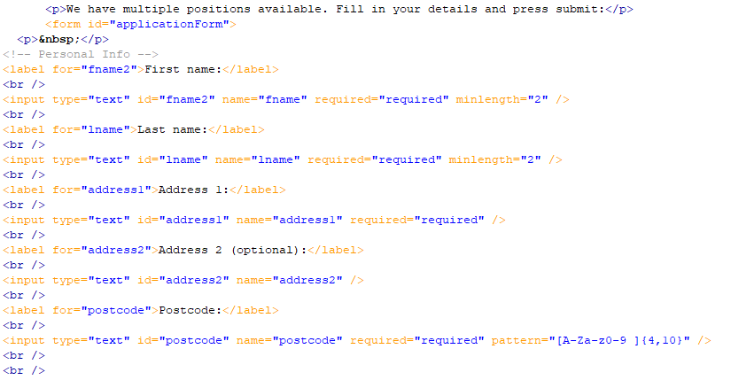I changed my JavaScript forms to add validation:

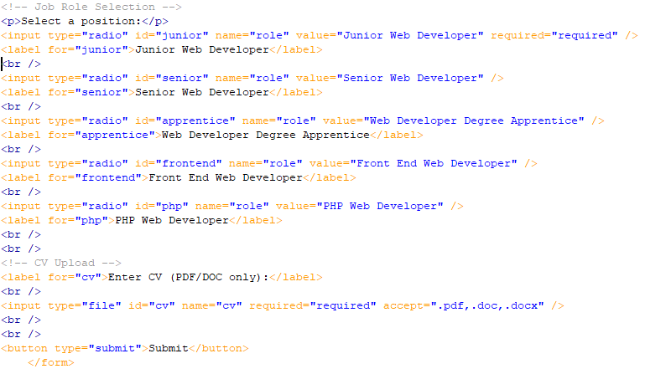

When running the website, the user will now encounter error messages for each error:

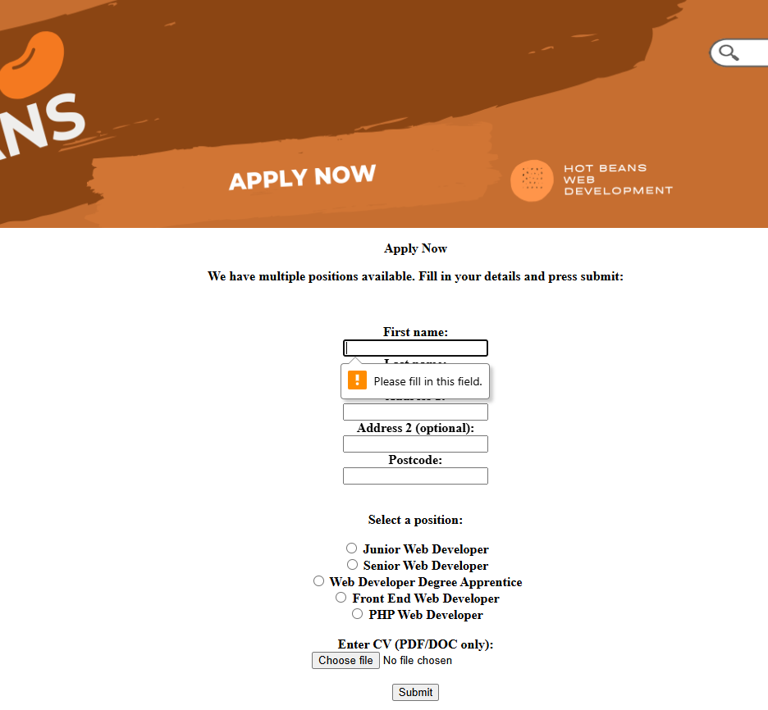

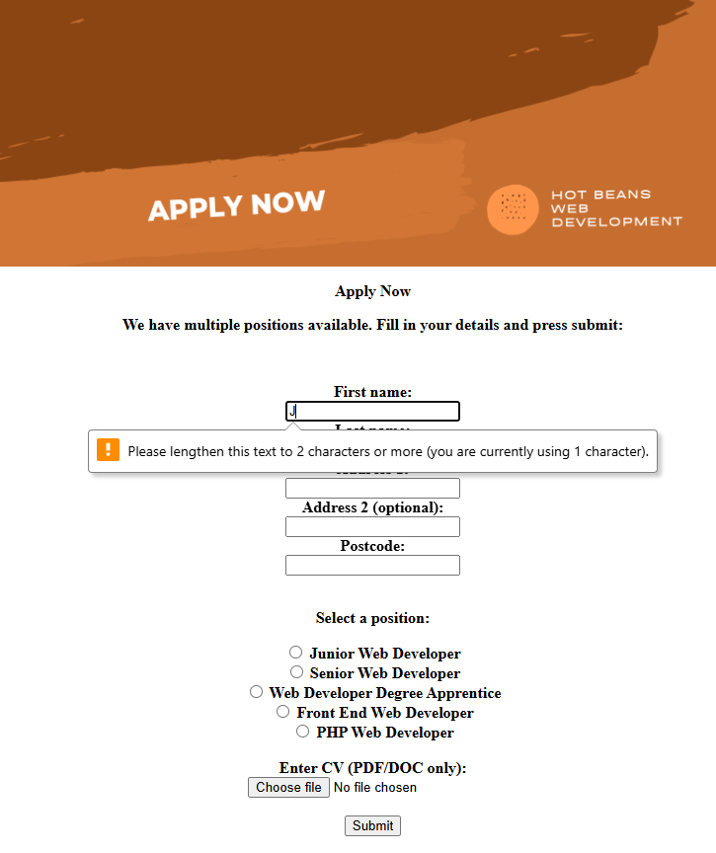

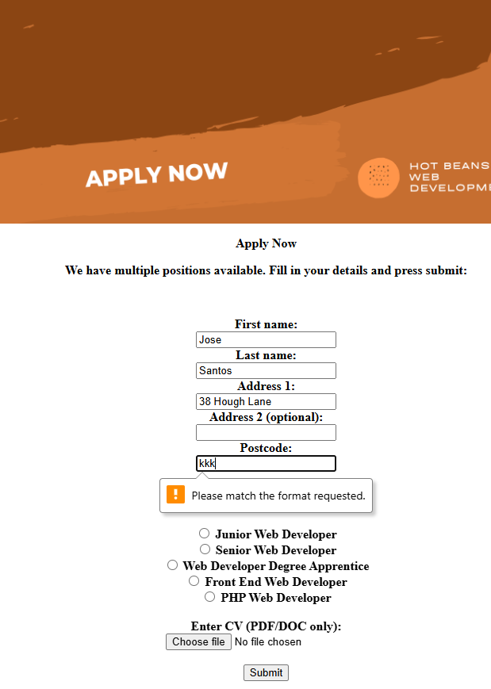

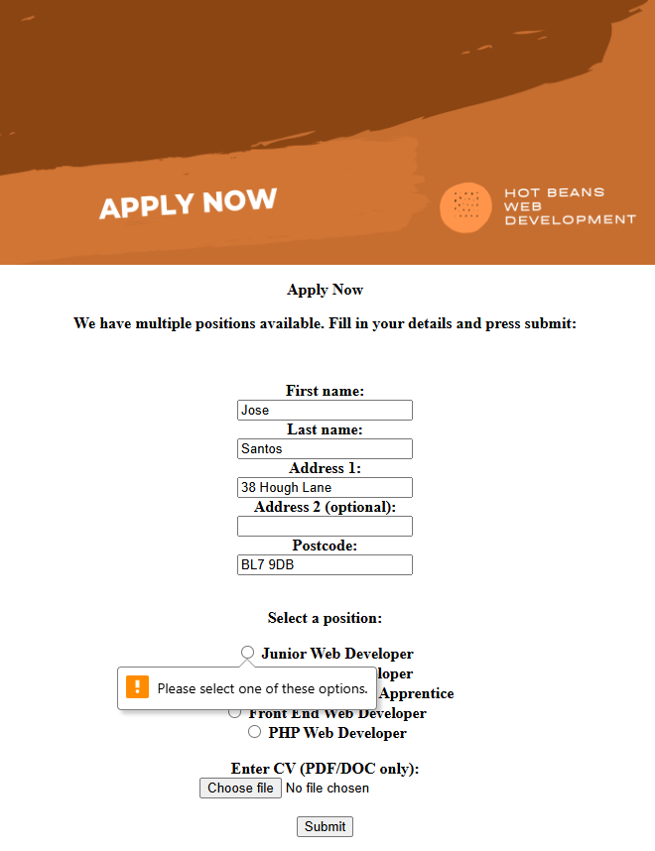

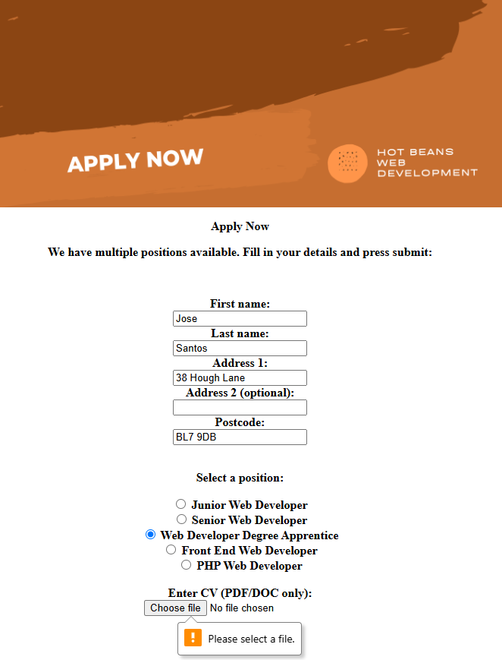

I now have Validation in my Apply Now Page, which guarantees users do not miss any fields that they must fill in.

The third error / bug I encountered was Unoptimized Images – Images are larger than needed, slowing the page down. This was a simple fix, as all I needed was a compression software which reduced the file size without significant quality loss. I decided to use TinyPNG to compress all of my assets to make them a smaller file size, in order to increase load time and improve my websites performance. I did this to all of my assets, for example, about us description.

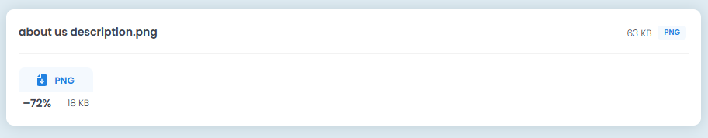

This resulted in a -72% file size, which is a massive reduction.

I did this process for every asset I had with the average percentage lost being 70-76%, meaning the overall file size of my website was much smaller, so the website could run a lot faster.

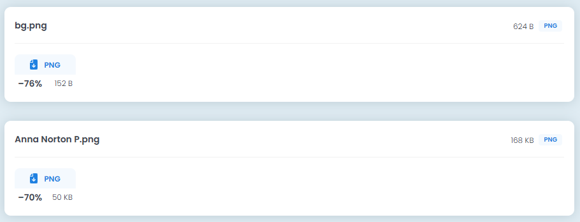

All my bugs / conveniences were fixed, creating a pleasant and enjoyable user experience.

**Final Evaluation**

**Meeting Requirements**

These were my requirements I wanted to meet at the start of the website:

* A Profile for the Company itself
* Profiles for existing web developers
* Job Descriptions and Required Qualifications
* Online Application Form
* External Links
* Appropriate Design for a Target Audience

I ended up meeting all of these requirements.

Starting with “A Profile for the Company itself” – I completed this requirement through my About Us Page and Profiles Page. In my About Us page, I added descriptions about what the company includes, such as their values and the quality they produce. I also included a section on the founding of Hot Beans, which helps a user understand much more about the company, to let them know what they are getting into. In my profiles page, I included 4 profiles of current employees. This proves to a user that Hot Beans supports their employees, and elevates their skills and work ethic.

Next, “Profiles for existing web developer” – I mentioned completing this in the previous requirement. Like I said, I created 4 profiles for existing web developers at Hot Beans, which improves user engagement, increasing the overall site engagement. If my website was simply just an application submission, the time spent on the website would be minimal. Including this requirement increases that time spent.

Next, “Job Descriptions and Required Qualifications” – I have completed this requirement through my Home Page slider and Jobs Page. Both these pages provide recommended jobs for users to apply for, which include the job descriptions for the corresponding job. On the jobs page, I created buttons which take the user to existing similar job role website, such as Indeed, which tell the user all of the fine details of the role, including the Required Qualifications for the role.

Next, “Online Application Form” – I have completed this requirement through my Apply Now page. This page consists of the entire form, using JavaScript forms and validation to allow the user to apply to the job of their choice in real time. This online application form consists of Name, Address, Post Code, The type of job and CV. Once the submit button is clicked, the user will be taken to a thank you screen, where it states that their application has been submitted and is in review.

Next, “External Links” – I mentioned completing this in one of the previous requirements. Like I said, in the jobs page, I created buttons which contain external links to existing similar job roles, where the user can fully understand what the job includes, along with required qualifications needed for the role.

Finally, “Appropriate Design for a Target Audience” – I completed this requirement throughout my entire website. My colour scheme, fonts, tone, and overall style were all stated in my mood board section. I aligned my website’s features, needs, preferences and behaviours of that of the target audience. I used a consistent visual style, using 3 shades of caramel. I ensured my website is easy to navigate, with intuitive menus and a logical structure. Ultimately, my website is definitely appropriate for a target audience.

**Evaluating my Performance**

Throughout all of the stages of developing my Hot Beans website, I demonstrated a strong and well-rounded performance in developing my website, showcasing both technical proficiency and a clear understanding of user-centered design. From the initial planning stages to deployment, my approach was methodical and aligned with best practices in modern web development.

I began with understanding the requirement of the website, as my employers told me that these requirements needed to be met to make the website accessible. Once I established the requirements I needed, I began to design 3 different layouts that I could make my website look like. I decided to make surveys for 100 different people in 5 different fields to get the most feedback I could in order to make sure I make the right decision. I went with the layout that gained the most positive feedback. I then had to establish colours and a theme, eventually designing a mood board to sum up the theme of my project. I went with variants of shades of caramel, with a coffee beans kind of style. I moved on to my time management preparation, where I designed a Gantt chart to support the amount of time I needed for each stage of development. The last section of my design was to establish and create the assets that I would include in my website, with a description and justification of why I was using them and why they looked the way they do. I then justified my decision making. I finished off my design with the technical constraints of my website, which included finishing on a deadline, and making sure I did not offend any computer related legislation.

Moving on to my development, I successfully developed the website using the correct assets and theme, meeting all of the requirements necessary, and I managed to complete this in the given time frame. However, it wasn’t a simple task. I used my problem solving and adaptability skills throughout my development process when I encountered errors, as I took the time to understand the error and fix it. I adjusted my approach when necessary and continuously improved the site based on my feedback. I organised my workflow efficiently, met my deadlines and maintained clear documentation.

Overall, my performance in developing the Hot Beans Website was highly commendable. My combined creativity with technical skills to deliver a product that not only functions effectively, but also aligns with user expectations and business goals. My work reflects a high standard of professionalism and a strong protentional for future success in web development.